When Does Model Complexity Pay Off? A Forecast-Horizon Crossover in Power-Sector CO₂ Emissions
Ikram Moulay^{1,†}, Moussa Redah², Sahar Merrouche³, Yousef A. Alsunni¹, Omar J. Hammad²
¹Department of Chemical Engineering, King Fahd University of Petroleum & Minerals, Dhahran 31261, Saudi Arabia
²Information and Computer Science Department, King Fahd University of Petroleum and Minerals, Dhahran, Saudi Arabia
³Department of Chemistry, King Fahd University of Petroleum & Minerals, Dhahran 31261, Saudi Arabia
† Corresponding Author Email: kamymoulay@kaist.ac.kr

Highlights

Ridge leads at 1 day, but HGB gains steadily beyond the 3-day crossover.

Persistence R² falls from 0.81 to 0.04 as the HGB advantage increases.
- GAM reproduces most aggregate long-horizon gains without explicit higher-order interactions.

The horizon effect remains significant with state-clustered inference.

The crossover persists under a substantially larger hyperparameter search.

Abstract
Does model complexity improve power-sector CO₂ forecasting? We evaluate ridge regression, histogram gradient boosting (HGB), and a generalized additive model (GAM) using seven complete years (2019-2025) of daily U.S. Environmental Protection Agency Clean Air Markets Program Data from 45 states at seven forecast horizons (1, 2, 3, 5, 7, 10, and 14 days; 315 state–horizon comparisons). Model performance exhibits a smooth horizon-dependent crossover. Ridge is marginally favored at one day (mean ΔR² = R²HGB - R²ridge = -0.0065), the gap crosses zero near three days, and HGB gains steadily thereafter, reaching +0.108 at fourteen days. This horizon effect remains significant under state-clustered inference (45 clusters, p < 10⁻⁶) and is directionally consistent across all four Census regions. The crossover closely tracks declining autoregressive persistence: median persistence R² falls from 0.81 at one day to 0.44 at three days and 0.04 at fourteen days, with persistence correlating with the HGB-ridge gap across all observations (r = -0.68). Nationwide GAM results show that smooth univariate nonlinearities reproduce most of HGB’s long-horizon advantage: GAM–ridge reaches +0.101 at fourteen days, HGB–GAM remains small overall, and GAM-ridge correlates strongly with the total HGB-ridge gap (r = 0.90). The crossover is essentially unchanged under a substantially larger hyperparameter search. These results show that model superiority is horizon-dependent and that the value of nonlinear flexibility increases as autoregressive persistence decays, largely without requiring higher-order feature interactions.
Keywords: CO₂ emissions forecasting; forecast horizon; gradient boosting; autoregression; additive models; power sector

1. Introduction
Power-sector CO₂ emissions vary substantially over short timescales as electricity demand, renewable generation, fuel use, generator availability, and dispatch conditions change. Forecasting these variations is increasingly relevant to emissions-aware electricity operation, flexible-load scheduling, and carbon-aware computing [4], [21]. The electricity sector remains a major source of global CO₂ emissions and a central component of decarbonization because electrification can displace fossil-fuel use in transportation, buildings, and industry [25]-[27]. Consequently, improving the ability to anticipate near-term changes in electricity-sector emissions has both operational and environmental value.
Growing interest in these applications has encouraged a transition from conventional regression and autoregressive approaches toward increasingly flexible machine-learning models. Recent carbon- and energy-forecasting studies have applied artificial neural networks, recurrent architectures, support-vector methods, decomposition-assisted approaches, and boosted decision trees [1], [4], [14], [23], while gradient-boosting methods have also shown strong predictive performance in related electricity-load forecasting problems [24]. These approaches are typically motivated by their ability to represent nonlinear relationships among historical emissions, electricity demand, generation conditions, weather, and system operation. However, evidence that a nonlinear model performs well at a particular forecast horizon does not establish that its advantage is constant across horizons.
Forecast horizon may itself alter the type of predictive structure available to a forecasting model. At very short horizons, power-sector emissions can exhibit strong autoregressive persistence because current operating conditions remain informative about the immediate future. Under such conditions, a relatively simple linear model can exploit the dominant temporal signal efficiently, while additional nonlinear flexibility may provide little incremental benefit and can increase estimation variance. As the forecast horizon lengthens, however, persistence should weaken and the remaining forecastable structure may depend increasingly on nonlinear relationships among historical emissions, operational variables, and temporal characteristics. The relative advantage of nonlinear over linear models may therefore be horizon-dependent rather than fixed.
Existing studies provide evidence that forecast accuracy changes with horizon but do not fully resolve this model-complexity question. Bokde et al. [4] demonstrated the relevance of short-term CO₂ forecasting to electricity-market scheduling. Leerbeck et al. [16] examined power-grid CO₂ emission-intensity forecasts across horizons from 1 to 24 h and showed that forecast error changes systematically with horizon, but did not test whether the relative ranking of linear and nonlinear model families changes with horizon. CarbonCast [17] extended carbon-intensity prediction from day-ahead to multi-day forecasting using a hierarchical machine-learning architecture, but was not designed as a controlled model-family-by-horizon comparison. Reviews of carbon-emission forecasting similarly report substantial heterogeneity in the apparent gains obtained from nonlinear methods [14], [23]. Thus, the literature reviewed here establishes that horizon affects forecast difficulty, but does not establish whether the value of additional model flexibility itself follows a systematic trajectory as horizon increases.
The unresolved question is therefore not simply whether nonlinear models can outperform linear models, but when additional nonlinear flexibility becomes valuable and why. Three related issues follow. First, does relative linear-versus-nonlinear performance undergo a reproducible crossover as forecast horizon increases rather than merely differ between isolated horizons? Second, does such a crossover coincide with the decay of autoregressive persistence, providing a statistical explanation for why model rankings change? Third, if nonlinear flexibility becomes advantageous at longer horizons, does that advantage require complex interactions among predictors, or can it be reproduced by smooth nonlinear effects of individual predictors? The present study addresses these questions jointly across multiple forecast horizons and a broad U.S. state panel.
The third question is especially important because superior performance of a tree ensemble does not, by itself, identify the source of its advantage. Histogram gradient boosting (HGB) can represent both nonlinear marginal responses and higher-order interactions among predictors. A generalized additive model (GAM) provides an informative intermediate level of flexibility: each predictor is allowed to have a smooth nonlinear relationship with the response, but cross-feature interaction terms are excluded by construction [11]. The resulting structural complexity ladder is:
$$\text{ridge }⟶\text{ GAM }⟶\text{ HGB}.$$
Ridge represents linear additive effects, the GAM represents smooth nonlinear additive effects, and HGB additionally permits interaction structure. If a GAM closes most of the ridge-to-HGB performance gap, higher-order interactions are not required to reproduce most of the nonlinear advantage. Conversely, if the GAM remains close to ridge while HGB performs substantially better, interactions become a more plausible explanation.
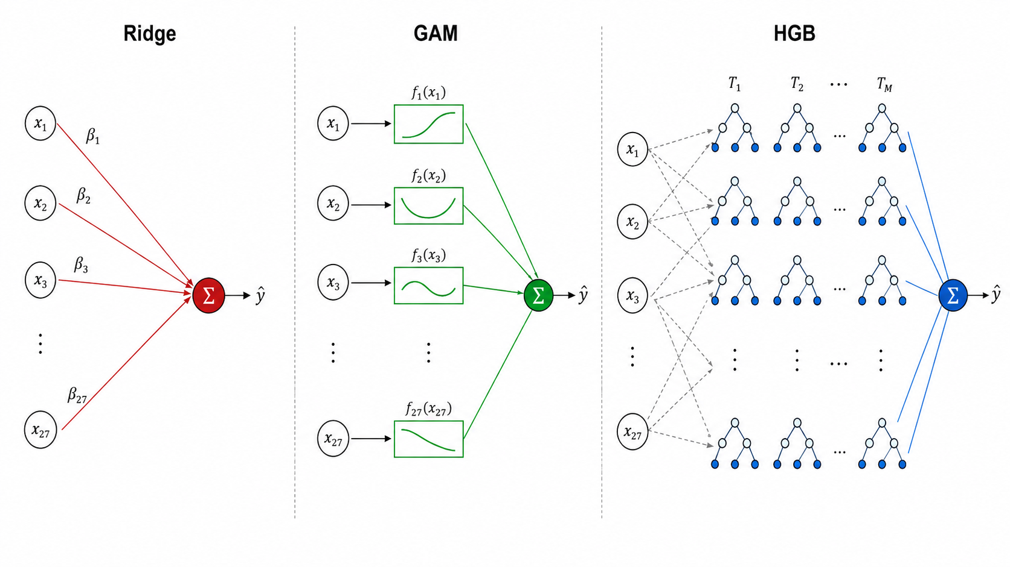
Fig. 1. Structural comparison of ridge, GAM, and HGB. Each model is fit on the identical 27-feature vector x(t); the models differ in functional flexibility, not predictor information.
Establishing a horizon-dependent model effect also requires careful comparative evaluation. Apparent differences between linear and nonlinear models can arise from feature construction, model-selection procedures, and evaluation design rather than from genuine differences in predictive structure. In particular, predictors that algebraically contain the forecasting target can create a representational asymmetry: a nonlinear learner may reconstruct information through multiplicative relationships that a linear model cannot form without explicit interaction terms. Hyperparameters selected using observations that occur after an earlier forecast origin can similarly introduce non-prospective information at the model-selection stage. Forecast-error sequences are also serially dependent, while comparisons repeated across states and horizons create a multiple-testing problem. A single chronological split may therefore support a different conclusion from a repeated rolling-origin evaluation even when nominal accuracy differences appear similar.
These concerns do not imply that conventional machine-learning forecasting studies are invalid; rather, they distinguish two different objectives. One objective is to obtain the lowest forecast error for a particular dataset and evaluation split. A more demanding objective is to claim that one model architecture is systematically superior to another across systems or forecast horizons. The latter requires greater control over feature representation, prospective model selection, temporal evaluation, dependent forecast errors, and multiplicity. Time-series cross-validation and rolling-origin evaluation provide appropriate frameworks for temporally ordered data [3], while the Diebold-Mariano framework [8], heteroskedasticity- and autocorrelation-consistent variance estimation [18], small-sample correction [10], and multiple-comparison procedures [13] provide established tools for inference on predictive differences. In this study, these safeguards are not treated as the primary contribution themselves; they provide the inferential foundation needed to determine whether an observed model-by-horizon pattern represents a reproducible forecasting phenomenon rather than an artifact of feature construction, tuning, or evaluation design.
Against this background, the present study evaluates short-term power-sector CO₂ forecasting using daily U.S. Environmental Protection Agency Clean Air Markets Program Data (CAMPD) [22]. The principal analysis covers seven complete years, 2019-2025, for 45 U.S. states meeting predefined data-quality criteria and considers seven forecast horizons of 1, 2, 3, 5, 7, 10, and 14 days. Ridge regression and HGB are used as deliberately contrasting model families, with persistence retained as the essential time-series baseline. A GAM is introduced as an intermediate complexity level to distinguish smooth additive nonlinearity from interaction-driven effects. A complementary detailed analysis of Texas, Pennsylvania, and California over 2023-2025 is used to diagnose sensitivity to feature representation, evaluation protocol, prospective hyperparameter selection, reporting-facility composition, and hyperparameter-search budget before the resulting framework is evaluated at nationwide scale.
The study makes four principal contributions. First, it reframes comparative power-sector CO₂ forecasting as a horizon-dependent problem and tests for a systematic model-performance crossover across seven forecast horizons rather than drawing conclusions from a single day-ahead or multi-day comparison. Second, it evaluates the generality of this behavior across 45 heterogeneous U.S. state power systems rather than inferring a general model ranking from a small number of individual systems. Third, it tests a specific explanation for the crossover by relating relative model performance to the decay of autoregressive persistence and by using a nationwide GAM decomposition to determine whether the emerging nonlinear advantage can be reproduced predominantly through smooth additive nonlinearities without requiring higher-order interactions. Fourth, it evaluates the resulting pattern within a leakage-aware, fully prospective, rolling-origin framework incorporating dependent-error inference, multiplicity control, regional dependence checks, and a substantially expanded hyperparameter-search robustness analysis.
The resulting objective is not to identify a universally superior forecasting architecture. Instead, it is to determine whether the relative value of model flexibility changes systematically as the forecasting problem becomes less dominated by short-term persistence, and to characterize the type of nonlinear structure associated with that transition.

1.1 Research questions
The analysis is organized around seven research questions that progress from methodological validity to nationwide generalization and mechanism identification.
RQ1. How much independent forecasting information is provided by CO₂ history, target-independent operational variables, and calendar characteristics when algebraically redundant target transformations are excluded?
RQ2. Under equivalent feature information and fully prospective hyperparameter selection, is the predictive performance of HGB statistically distinguishable from that of ridge regression after accounting for dependent forecast errors and multiple comparisons?
RQ3. To what extent do evaluation design and retraining protocol alter the estimated and inferential comparison between linear and nonlinear forecasting models?
RQ4. Does the relative performance of HGB and ridge depend systematically on the magnitude of day-to-day changes in CO₂ emissions?
RQ5. Are model rankings robust to changes in the composition of reporting facilities used to construct state-level emissions series?
RQ6. Do the model-comparison patterns observed in the three-state case study generalize across a broader sample of U.S. states, and does relative performance vary systematically with forecast horizon?
RQ7. Does horizon-dependent model performance form a reproducible crossover across multiple forecast horizons, is that crossover associated with the decay of autoregressive persistence, and can the resulting nonlinear advantage be explained predominantly by smooth additive relationships rather than higher-order feature interactions?
The first five questions establish the methodological conditions under which the model comparison can be interpreted reliably, whereas RQ6 and RQ7 address the central nationwide result: whether nonlinear flexibility becomes systematically more valuable as forecast horizon increases and what statistical structure accounts for that change.

2. Materials and Methods

2.1 Study design
The study evaluates whether the relative benefit of nonlinear model flexibility in short-term power-sector CO₂ forecasting changes with forecast horizon. The primary analysis uses seven years of EPA Clean Air Markets Program Data (2019-2025) from 45 U.S. states meeting predefined eligibility criteria and considers seven forecast horizons ranging from 1 to 14 days. A complementary three-state analysis of Texas, Pennsylvania, and California, using data from 2023–2025, is used to examine methodological sensitivities in greater detail, including redundant target encoding, prospective hyperparameter selection, feature representation, evaluation protocol, and retuning under an expanded search. The resulting evaluation framework is then applied consistently across the nationwide multihorizon analysis to determine whether the patterns observed in the case studies generalize across states and forecast horizons. All model comparisons use a common evaluation and statistical-testing framework to ensure that differences in predictive performance reflect model behavior rather than inconsistencies in experimental design. The overall analytical workflow is summarized in Fig. 2.
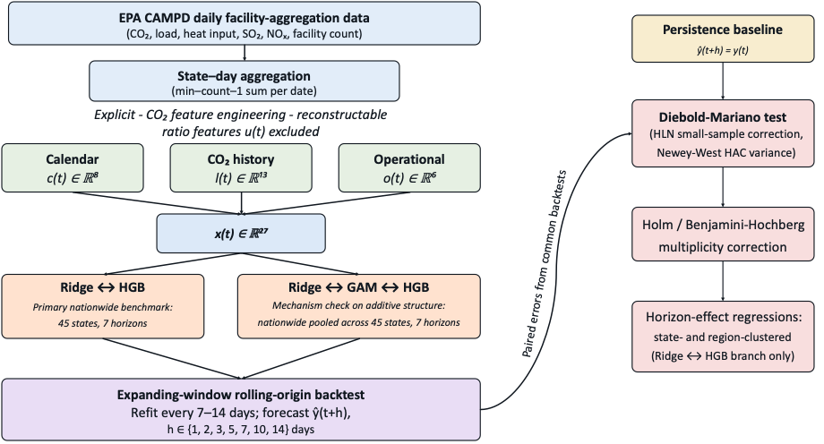
Fig. 2. Forecasting pipeline: primary nationwide benchmark

2.2 Data provision and state-level aggregation
Daily facility-level data were obtained from the U.S. Environmental Protection Agency Clean Air Markets Program Data (CAMPD) website [22]. The 2023-2025 exports contained facility identifier, state, gross load, steam load, SO₂ mass, CO₂ mass, NO_{x} mass, and heat input. After removing 2,519 duplicate state-facility-date records occurring at annual-export boundaries, the dataset contained 1,416,164 facility-day observations from 1,353 facilities across 51 state or district codes. State-level daily series were constructed by summing available facility observations for CO₂, SO₂, NO_{x}, gross load, and heat input; days with no reporting facilities were retained as missing rather than assigned zero. Steam load was excluded because 94.95% of observations were missing.

Texas (TX), Pennsylvania (PA), and California (CA) were selected for the detailed case-study analysis because of their contrasting emission levels, generation portfolios, and grid structures. Their state-day series were complete for all modeled variables over 2023-2025. The number of reporting facilities was retained as an operational covariate, CO₂ intensity was calculated as daily CO₂ mass divided by gross load, and calendar variables were derived from day of week, month, day of year, weekend status, and cyclical weekly and annual encodings. The three-state analysis and initial nationwide benchmark use the 2023-2025 period, whereas the multihorizon analysis extends the data window to 2019-2025. Table 1 summarizes the principal datasets and evaluation designs.
Table 1. Dataset and evaluation overview.
Item | Value
Facility-day records (2023-2025) | 1,416,164
Duplicate rows removed | 2,519
Unique facilities | 1,353
States/district codes | 51
Focus states | TX, PA, CA
State-day observations per focus state | 1,096
Forecast horizons: three-state case study and two-horizon nationwide benchmark | 1 day and 7 days
Forecast horizons: multihorizon benchmark | 1, 2, 3, 5, 7, 10, and 14 days
Temporal window: three-state case study and two-horizon nationwide benchmark | 2023-2025
Temporal window: multihorizon benchmark | 2019-2025
Evaluation designs | Single chronological split; expanding-window rolling-origin backtest, both with fully prospective hyperparameter selection

2.3 Predictor construction and forecasting formulation
Predictors were organized into four groups. Calendar variables comprised eight temporal features. CO₂ history comprised current-day CO₂ mass, lags at 1, 2, 3, 7, 14, and 30 days, and trailing 7-, 14-, and 30-day means and standard deviations calculated using observations strictly preceding day $t$. Target-independent operational variables comprised gross load, heat input, SO₂ mass, NO_{x} mass, reporting-facility count, and heat rate. Two additional current-emissions transforms, CO₂ intensity and the SO₂-to-CO₂ ratio, were retained only for diagnostic analysis.
The primary predictor vector contained the 27 calendar, CO₂-history, and operational variables,
$$x\left(t\right)=\left[c ; \left(t\right) ; l\left(t\right)o\left(t\right)\right].$$
The two current-emissions transforms were excluded from the primary specification because they algebraically contain the CO₂ target. In particular, including both gross load and CO₂ intensity makes current CO₂ mass reconstructable as their product. A nonlinear tree model can approximate such a product through successive splits, whereas a linear model cannot do so without an explicit interaction term. Retaining these variables could therefore create an artificial representational advantage unrelated to genuine forecasting ability. Current CO₂ mass itself was included directly and identically for all models, so excluding the ratio-based transforms does not remove the underlying information.
Ridge predictors were standardized using means and standard deviations estimated from the corresponding training data only; histogram gradient boosting (HGB) used the unstandardized predictors. For the three-state and two-horizon analyses, the target was future CO₂ mass at $h∈\left\{1 , 7\right\}$days, while the multihorizon analysis subsequently extended h to 1, 2, 3, 5, 7, 10, and 14 days. Current CO₂ mass, $y\left(t\right)$, was also retained as the persistence forecast.
All forecasts are conditional end-of-day forecasts: predictors measured for day t are used to predict CO₂ emissions at day $t+h$. The analysis therefore compares forecasting models under a common finalized information set rather than reproducing a real-time operational deployment. A deployed system would require contemporaneously available measurements or nowcasts of the operational variables used here.

2.4 Temporal evaluation and hyperparameter selection
Two chronological evaluation designs were considered. The first used a fixed 70%, 15%, 15% train-validation-test split with no shuffling. At the one-day horizon, this produced 745 training, 159 validation, and 161 test observations per state; the corresponding seven-day samples contained 741, 158, and 160 observations.
The primary evaluation used an expanding-window rolling-origin backtest [3]. Forecasting began after approximately 50% of each state series had accumulated. Models were then refitted every seven days and used to predict the subsequent seven-day block, producing approximately 530 out-of-sample forecasts per state and horizon over July 2024-December 2025. This design evaluates model performance repeatedly through time rather than relying on a single terminal test period.
Hyperparameter selection was prospective in both evaluation designs. Ridge and HGB were each assigned a 12-configuration search budget. Ridge regularization was selected from 12 candidate values, while the HGB search covered combinations of learning rate, tree depth, number of boosting iterations, and minimum leaf size. Candidate configurations were evaluated using only temporally prior training and validation observations.
For the fixed split, hyperparameters were selected within the pre-test training and validation data. For the rolling-origin analysis, selection was performed once using only the initial pre-forecast window; the selected configuration was then frozen for all subsequent forecast origins. Consequently, no forecast was generated using hyperparameters selected from observations occurring later than its forecast origin. A separate sensitivity analysis deliberately contrasts this procedure with non-prospective selection to quantify the influence of hyperparameter-selection chronology.
Because equal numbers of candidate configurations do not imply equal coverage of parameter spaces of different dimensionality, search-budget sensitivity was examined separately. The principal robustness analysis expanded the search to 30 ridge regularization values and 60 HGB configurations. For the detailed CA and TX one-day analyses, this larger search was combined with expanding-window temporal cross-validation; computationally lighter versions of the same 30-ridge/60-HGB search were subsequently applied to the nationwide and multihorizon analyses.

2.5 Forecasting models and statistical evaluation
Three forecasting approaches were considered in the primary analysis: persistence, ridge regression, and histogram gradient boosting (HGB). Persistence was retained as the zero-parameter time-series benchmark, with the forecast at horizon $h$given by the most recently observed CO₂ emission:
$$\hat{y}\left(t+h\right)=y\left(t\right)$$
Ridge regression was used as the regularized linear model and fitted on standardized predictors by minimizing
$$L\left(β\right)={∥y-Zβ∥}_{2}^{2}+λ{∥β∥}_{2}^{2}$$
where Z is the standardized predictor matrix, β is the coefficient vector, and λ is the regularization parameter. HGB was used as the nonlinear tree-based alternative [19]. Its learning rate, maximum tree depth, number of boosting iterations, and minimum leaf size were selected prospectively using the temporal validation procedure described above. Ridge and HGB were each assigned 12 candidate configurations in the primary analysis. Because an equal number of configurations does not necessarily provide equivalent coverage of parameter spaces with different dimensionality, sensitivity to search budget was subsequently evaluated using 30 ridge regularization values and 60 HGB configurations. XGBoost [6] and LSTM-based architectures [12] were also examined in supplementary analyses but were excluded from the principal statistical comparisons because they were not implemented under the complete prospective tuning framework used for ridge and HGB.
Differences in predictive accuracy between ridge and HGB were evaluated using the Diebold–Mariano (DM) test [8]. For the primary squared-error comparison, the forecast-loss differential was defined as
$$\begin{matrix} & d_{t}=e_{ridge,t}^{2}-e_{HGB,t}^{2} & & \text{(1)}\end{matrix}$$
where $e_{ridge,t}$ and $e_{HGB,t}$ denote the respective forecast errors. Thus, $d_{t}>0$ indicates lower squared error for HGB, whereas $d_{t}<0$ favors ridge. Absolute-error loss differentials were also evaluated as a robustness check. The uncorrected DM statistic was calculated as
$$\begin{matrix} & DM=\frac{\overline{d}}{\sqrt{\hat{Var}\left(\overline{d}\right)}} & & \text{(2)}\end{matrix}$$
where $\overline{d}$ is the mean loss differential and $\hat{Var}\left(\overline{d}\right)$is estimated using the Newey-West heteroskedasticity- and autocorrelation-consistent estimator with a Bartlett kernel [18]. To account for serial dependence arising from overlapping multistep forecasts, the truncation lag was defined as:
$$q=\max\left[h , -1 \left\lfloor 4{\left(\frac{n}{100}\right)}^{2/9}\right\rfloor \right]$$
so that it could not fall below h-1 for an h-day forecast. Statistical inference was based on the Harvey-Leybourne-Newbold small-sample correction [10]:
$$\begin{matrix} & DM_{HLN}=DM\sqrt{\frac{n+1-2h+\frac{h\left(h-1\right)}{n}}{n}} & & \text{(3)}\end{matrix}$$
The corrected statistic was evaluated against a Student-$t$ distribution with n-1 degrees of freedom. Alternative HAC lag choices were examined in sensitivity analyses.
Confidence intervals for model-performance differences were estimated using a moving-block bootstrap, preserving short-range temporal dependence rather than independently resampling forecast observations [9], [15]. A seven-day block length was used in the primary analysis to reflect the weekly cycle in the data, while 14- and 28-day blocks were considered as sensitivity checks. Because model comparisons were repeated across multiple states and forecast horizons, Holm's step-down procedure [13] and the Benjamini-Hochberg procedure [2] were used to control the family-wise error rate and false discovery rate, respectively. Adjustments were applied to the complete family of comparisons relevant to each analysis.
The relationship between model performance and abrupt day-to-day changes in emissions was examined using the absolute CO₂ ramp:
$$r_{t}=∣y_{t}-y_{t-1}∣$$
and the regression:
$$\begin{matrix} & d_{t}=β_{0}+β_{1}r_{t}+ε_{t} & & \text{(4)}\end{matrix}$$
with Newey-West HAC standard errors. The corresponding null hypothesis was:
$$H_{0}:β_{1}=0$$
so that rejection indicates a systematic relationship between ramp magnitude and the relative squared-error performance of ridge and HGB.
Forecast performance was summarized using root-mean-square error (RMSE), mean absolute error (MAE), mean absolute percentage error (MAPE), and the coefficient of determination (R²):
$$\begin{matrix} & RMSE=\sqrt{\frac{1}{n}\sum_{i=1}^{n}{{\left(y_{i}-{\hat{y}}_{i}\right)}^{2}}} & & \text{(5)}\end{matrix} \\ \begin{matrix} & MAE=\frac{1}{n}\sum_{i=1}^{n}{∣y_{i}-{\hat{y}}_{i}∣} & & \text{(6)}\end{matrix} \\ \begin{matrix} & MAPE=\frac{100}{n}\sum_{i=1}^{n}{∣\frac{y_{i}-{\hat{y}}_{i}}{y_{i}}∣} & & \text{(7)}\end{matrix} \\ \begin{matrix} & R^{2}=1-\frac{\sum_{i=1}^{n}{{\left(y_{i}-{\hat{y}}_{i}\right)}^{2}}}{\sum_{i=1}^{n}{{\left(y_{i}-\overline{y}\right)}^{2}}} & & \text{(8)}\end{matrix}$$
RMSE and MAE are reported in short tons of CO₂, whereas MAPE is expressed as a percentage. R² was used as the principal scale-independent performance measure for comparisons among states with substantially different emission levels [7], while persistence was retained as a separate forecasting baseline.
The magnitude of the ridge-HGB difference was additionally expressed as the percentage reduction in RMSE obtained by HGB relative to ridge:
$$\begin{matrix} & ΔRMSE\left(\%\right)=100\left(\frac{RMSE_{ridge}-RMSE_{HGB}}{RMSE_{ridge}}\right) & & \text{(9)}\end{matrix}$$
Positive values therefore favor HGB, whereas negative values favor ridge. Confidence intervals for $ΔRMSE$were obtained using the moving-block bootstrap.
Two diagnostic analyses were conducted within the three-state case study. Feature-group ablation was performed under the same rolling-origin evaluation framework as the primary analysis, with the ridge regularization parameter selected prospectively for each predictor subset. Sensitivity to facility-reporting composition was examined by reconstructing each state series using only facilities reporting CO₂ on at least 95% of the 1,096 days during 2023-2025 and repeating the persistence, ridge, and HGB comparison. These analyses assessed whether model rankings were materially influenced by predictor composition or changes in the reporting facility panel.

2.6 Nationwide and multihorizon analysis
The three-state analysis was extended to a nationwide benchmark using eligibility criteria specified before model comparison. A state or district was retained if daily CO₂ mass was observed on at least 98% of the analysis period, at least five facilities contributed observations, mean daily CO₂ emissions were at least 5,000 short tons, the coefficient of variation of daily emissions was at least 0.05, and no sequence of missing observations exceeded 14 consecutive days. Applying these criteria to the 2023-2025 CAMPD dataset retained 47 of the 51 state or district codes. Alaska, the District of Columbia, and Puerto Rico had insufficient qualifying facility coverage, while Vermont did not satisfy the completeness and maximum-gap criteria. The resulting nationwide benchmark therefore comprised 47 states evaluated at one- and seven-day horizons, yielding 94 state-horizon comparisons.
The nationwide benchmark used the same predictor definitions, prospective hyperparameter selection, expanding-window evaluation, and dependent-error testing procedures as the three-state analysis. Holm and Benjamini–Hochberg corrections were applied jointly across the complete family of 94 ridge-HGB comparisons, ensuring that the statistical treatment remained consistent across the case-study and nationwide analyses.
For the principal multihorizon analysis, CAMPD records for 2019-2022 were combined with the 2023-2025 data, extending the observation period to seven complete years, from 1 January 2019 through 31 December 2025. The eligibility criteria were reapplied to the full period rather than carried forward from the shorter dataset. Idaho and Maine, although eligible over 2023–2025, did not satisfy the completeness or maximum-gap requirements over the seven-year period, resulting in a final panel of 45 states.
The set of forecast horizons was expanded to:
$$h∈\left\{1 , 2 , 3 , 5 , 7 , 10 , 14\right\}\text{ days}$$
giving a total of 315 state-horizon comparisons. The more closely spaced short horizons were selected to resolve changes in relative model performance over the interval in which autoregressive persistence was expected to weaken most rapidly, while the 10- and 14-day horizons extended the analysis to a two-week forecast window. The expanding-window evaluation design was retained, although the refitting interval was increased from 7 to 14 days to maintain a computational burden comparable with that of the shorter three-year analysis. This produced approximately 90 forecast origins for each state–horizon combination.
Hyperparameters were selected prospectively for each state–horizon combination using only information available before the corresponding forecast sequence. The HLN-corrected DM procedure was subsequently applied to all 315 ridge-HGB comparisons, with Holm and Benjamini-Hochberg adjustments calculated across the complete multihorizon family. National mean differences were evaluated across states rather than treating individual forecast observations as independent cross-sectional replicates. The full seven-horizon analysis was also repeated using the expanded 30-ridge/60-HGB hyperparameter search to assess whether the horizon-dependent pattern was sensitive to the initial search budget.

2.7 Additive-model decomposition and dependence-aware inference
A generalized additive model (GAM) was introduced as an intermediate level of model flexibility between ridge regression and HGB to determine whether nonlinear forecasting gains were attributable primarily to smooth predictor–response relationships or to higher-order interactions [11]. For p predictors, the GAM was expressed as:
$$\hat{y}=β_{0}+\sum_{j=1}^{p}{f_{j}}\left(x_{j}\right)$$
where $f_{j}\left(x_{j}\right)$ is a smooth function of the $j$th predictor. Because the model contains no cross-feature interaction terms, it permits nonlinear marginal relationships while remaining additive across predictors. Each standardized predictor was represented using a cubic B-spline basis with five knots, and the resulting basis coefficients were estimated under ridge regularization. The regularization strength was selected prospectively using the same temporal validation procedure applied to ridge.
The GAM was evaluated using the same 27 predictors, rolling-origin design, and seven forecast horizons as ridge and HGB for all 45 multihorizon-eligible states. The three models therefore differed in functional flexibility rather than predictor information: ridge represents linear additive effects, the GAM allows smooth additive nonlinear effects, and HGB additionally permits higher-order interactions. The GAM-ridge difference was used to quantify the contribution of smooth additive nonlinearity, while the remaining HGB-GAM difference quantified predictive gains not reproduced by the additive specification.
Because each state contributes repeated observations across seven forecast horizons, the nationwide horizon effect was evaluated using cluster-robust regression. For state $s$and forecast horizon $h$, relative model performance was defined as:
$$Δ_{s,h}=R_{HGB,s,h}^{2}-R_{ridge,s,h}^{2}$$
and modeled as:
$$\begin{matrix} & Δ_{s,h}=β_{0}+β_{1}h+ε_{s,h} & & \text{(10)}\end{matrix}$$
using all 315 state–horizon observations. Standard errors were clustered separately by state and by U.S. Census region. State clustering ($G=45$) accounts for repeated horizon observations within individual states, whereas Census-region clustering allows dependence among states within the same broad geographic region.
The cluster-robust covariance estimator incorporated the CR1 finite-sample correction,
$$\begin{matrix} & c_{CR1}=\frac{G}{G-1}\frac{N-1}{N-K} & & \text{(11)}\end{matrix}$$
where $G$ is the number of clusters, $N$is the number of observations, and $K$is the number of estimated regression parameters. The resulting cluster-robust $t$-statistics were evaluated against a Student-$t$ distribution with G – 1 degrees of freedom.
Because the Census-region analysis contains only four clusters, conventional asymptotic cluster-robust inference has limited small-sample reliability. The regional analysis was therefore supplemented with an exact wild-cluster sign-flip test [5]. Under the null hypothesis of no horizon effect, pseudo-outcomes were generated as:
$$y^{*}={\hat{y}}_{restricted}+w{\tilde{ε}}_{restricted}$$
where ${\tilde{ε}}_{restricted}$ denotes the residuals from the intercept-only restricted model and
$$w∈\left\{- , 1+1\right\}$$
assigns an independent sign to each region. With four Census regions, the complete set of possible assignments is 16 and all 16 sign combinations were enumerated rather than approximated by simulation. The two-sided permutation $p$-value was calculated as the proportion of assignments producing a cluster-robust test statistic at least as extreme as that obtained from the observed data.

3. Results and Discussion

3.1 Emission patterns and predictive information
Across 2023-2025, TX emitted 635.29 million short tons of CO₂, PA 235.82 million, and CA 97.60 million. Mean daily CO₂ emissions were approximately 579,644 short tons in TX, 215,166 short tons in PA, and 89,050 short tons in CA, with corresponding standard deviations of approximately 149,053, 50,325, and 39,452 short tons. Annual CO₂ emissions increased by 1.11% in TX and 9.57% in PA between 2023 and 2025, whereas CA experienced a 23.75% reduction. Over the same period, CO₂ intensity declined by 0.52% in TX and 3.75% in CA but increased by 4.33% in PA. The daily and annual emission profiles are shown in Fig.3.
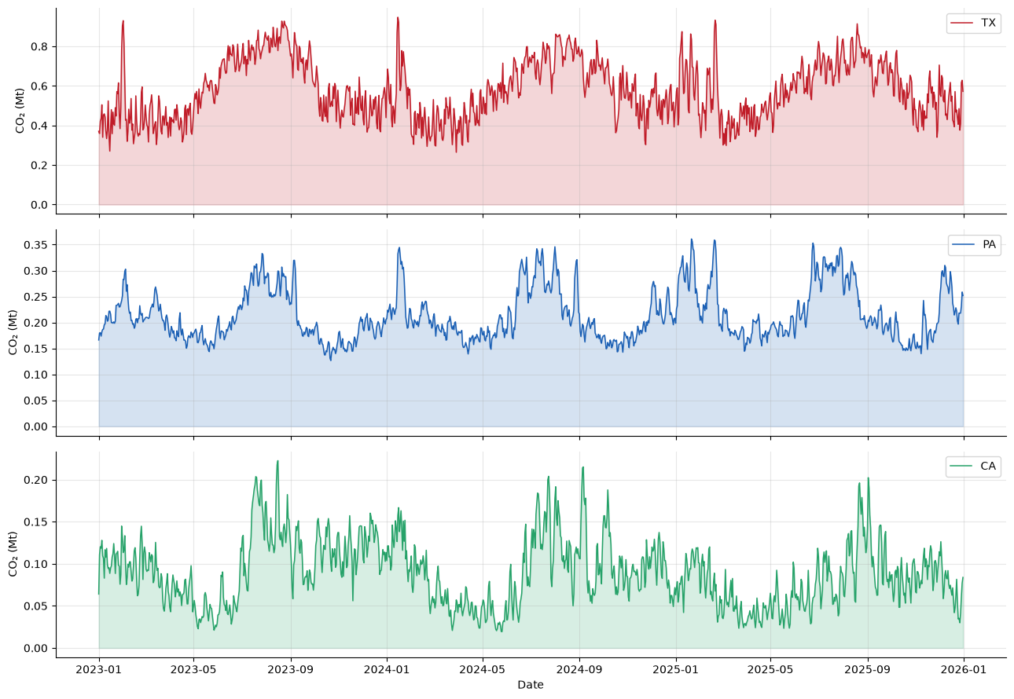
Fig. 3. Daily state-level CO₂ mass, TX/PA/CA, 2023-2025.
The rolling-origin feature-group ablation provides a more detailed view of the information underlying short-horizon predictability. Calendar variables alone provided limited predictive skill, with one-day R² values of 0.401 in TX, 0.003 in PA, and 0.230 in CA. In contrast, CO₂ history alone, including the current day's observed CO₂ value, achieved R² values of 0.752, 0.926, and 0.817, respectively. These values were comparable with or higher than those obtained using the target-independent operational variables alone, which produced R² values of 0.723, 0.913, and 0.785.
Combining CO₂ history with operational variables produced only small changes in predictive performance. The corresponding R² increased by 0.013 in TX, from 0.752 to 0.765, decreased marginally from 0.926 to 0.925 in PA, and remained unchanged at 0.817 in CA. The current-emissions transforms, comprising CO₂ intensity and the SO₂-to-CO₂ ratio, were retained only as a diagnostic feature group. Because these quantities are deterministic functions of variables represented elsewhere in the predictor set, they were excluded from the primary specification to prevent redundant target encoding rather than because their standalone predictive performance was necessarily expected to be poor.
The additional contribution of operational information beyond CO₂ history was tested using both a paired Diebold-Mariano comparison and an independent moving-block bootstrap. The DM test identified no significant improvement in any state: TX $p=0.1198$, PA $p=0.3080$, and CA $p=0.9981$. After Holm correction across the three comparisons, the corresponding values were 0.3594, 0.6160, and 0.9981. The moving-block bootstrap led to the same conclusion, with the 95% confidence interval for the squared-error differential including zero in all three states.
Table 2. Does operational data add a statistically distinguishable increment beyond CO₂ history? (Rolling-origin, one-day horizon, paired Diebold-Mariano test.)
State | R² history only | R² history + operational | DM statistic | p | Holm p
TX | 0.752 | 0.765 | +1.558 | 0.1198 | 0.3594
PA | 0.926 | 0.925 | −1.020 | 0.3080 | 0.6160
CA | 0.817 | 0.817 | +0.002 | 0.9981 | 0.9981

Table 3. Rolling-origin feature-group ablation (ridge, one-day horizon, prospectively selected λ per group).
State | Feature group | N feat. | R²
TX | Calendar only | 8 | 0.401
TX | CO₂ history only (incl. today) | 13 | 0.752
TX | Operational only | 6 | 0.723
TX | History + operational | 19 | 0.765
TX | Current-emissions transforms only | 2 | -0.127
TX | Full (history + operational + calendar) | 27 | 0.745
PA | Calendar only | 8 | 0.003
PA | CO₂ history only (incl. today) | 13 | 0.926
PA | Operational only | 6 | 0.913
PA | History + operational | 19 | 0.925
PA | Current-emissions transforms only | 2 | 0.429
PA | Full (history + operational + calendar) | 27 | 0.929
CA | Calendar only | 8 | 0.230
CA | CO₂ history only (incl. today) | 13 | 0.817
CA | Operational only | 6 | 0.785
CA | History + operational | 19 | 0.817
CA | Current-emissions transforms only | 2 | 0.108
CA | Full (history + operational + calendar) | 27 | 0.834
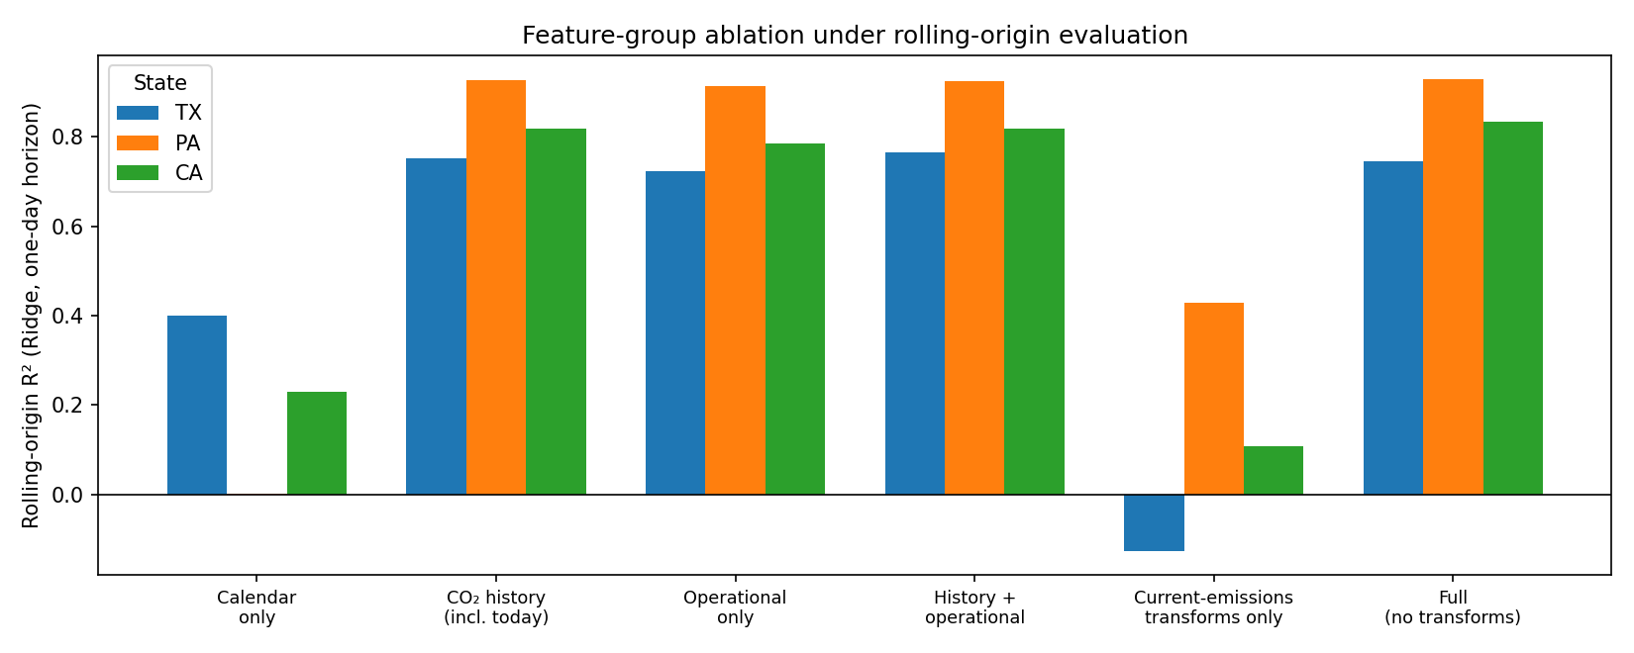
Fig. 4. Feature-group ablation under rolling-origin evaluation for Texas, Pennsylvania, and California.
The full specification was not invariably the best out-of-sample feature grouping. In TX, for example, the history-plus-operational subset achieved $R^{2}=0.765$, compared with 0.745 for the full specification. Calendar variables therefore provided no additional out-of-sample benefit in TX once emissions history and operational variables were already available and slightly reduced rolling-origin skill under this specification. Because each feature subset received its own independently selected regularization parameter, part of this difference may also reflect variation in the selected regularization strength for the higher-dimensional full model rather than an adverse contribution from the calendar variables themselves. The available analysis does not separate these two effects.
Taken together, the ablation indicates that recent CO₂ history accounts for the majority of forecastable one-day signal in all three states. Target-independent operational data contain substantial predictive information when considered alone, but their incremental contribution after emissions history is included is not statistically distinguishable from sampling variation. This is consistent with the two information sources being overlapping manifestations of the same underlying demand, dispatch, and generation processes rather than independent sources of short-term forecasting skill.

3.2 Evaluation design and the primary three-state comparison
The influence of evaluation design was first examined by comparing the fixed chronological split with the expanding-window rolling-origin framework. As shown in Table 3, point estimates for ridge and HGB were generally similar across the two designs, with differences of approximately 0.03–0.06 R² or less in most cases. This superficial similarity, however, did not imply that the two designs necessarily supported the same inferential conclusions.
Table 4. One-day-ahead R² under single-split and rolling-origin evaluation.
State | Model | Single split (n=161) | Rolling-origin (n=533)
TX | Persistence | 0.699 | 0.716
TX | Ridge | 0.732 | 0.745
TX | HGB | 0.749 | 0.758
PA | Persistence | 0.916 | 0.912
PA | Ridge | 0.938 | 0.929
PA | HGB | 0.928 | 0.925
CA | Persistence | 0.674 | 0.766
CA | Ridge | 0.753 | 0.834
CA | HGB | 0.786 | 0.813

Using the same HLN-corrected Diebold-Mariano procedure under both designs, the largest discrepancy occurred for CA at the one-day horizon. The single-split analysis favored HGB ($DM=2.199$, $p=0.0293$), whereas the rolling-origin analysis favored ridge ($DM=-3.111$, $p=0.0020$). After Holm correction within each design's six-comparison family, only the rolling-origin result remained significant ($p_{Holm}=0.0118$); the single-split result did not ($p_{Holm}=0.1757$). PA at seven days showed a related difference: the single split found no evidence of different predictive accuracy ($p=0.5685$), whereas the rolling-origin comparison was nominally significant ($p=0.0249$) but did not survive Holm correction ($p_{Holm}=0.1246$).
Table 5. Ridge-vs-HGB Diebold-Mariano test (HLN-corrected), single split vs. rolling-origin, with Holm correction applied within each design’s own family of six tests.
State | Horizon | Design | N | DM stat. | p | Holm p
TX | 1 | Single split | 161 | 0.801 | 0.4245 | 1.0000
TX | 1 | Rolling-origin | 533 | 1.196 | 0.2324 | 0.9295
PA | 1 | Single split | 161 | -1.250 | 0.2133 | 0.8531
PA | 1 | Rolling-origin | 533 | -1.191 | 0.2343 | 0.9295
CA | 1 | Single split | 161 | 2.199 | 0.0293 | 0.1757
CA | 1 | Rolling-origin | 533 | -3.111 | 0.0020 | 0.0118
TX | 7 | Single split | 160 | 1.701 | 0.0909 | 0.4543
TX | 7 | Rolling-origin | 530 | 1.000 | 0.3176 | 0.9295
PA | 7 | Single split | 160 | -0.571 | 0.5685 | 1.0000
PA | 7 | Rolling-origin | 530 | 2.249 | 0.0249 | 0.1246
CA | 7 | Single split | 160 | -0.931 | 0.3532 | 1.0000
CA | 7 | Rolling-origin | 530 | 0.717 | 0.4737 | 0.9295

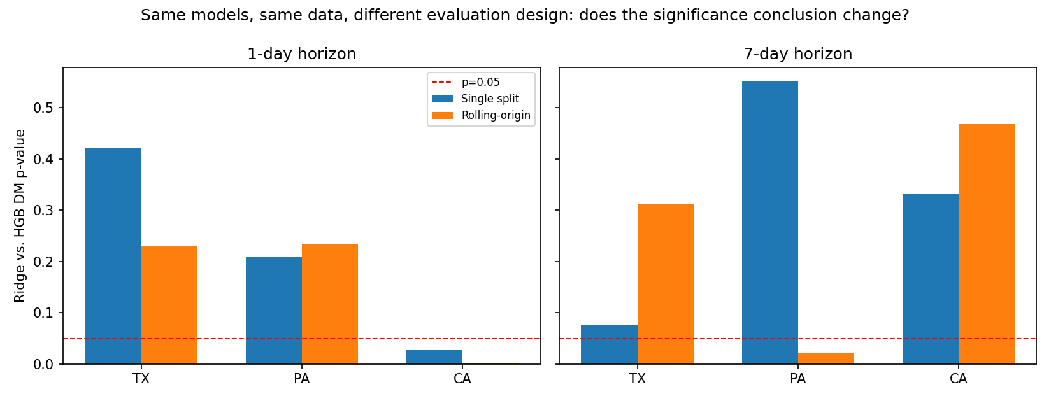
Fig. 5. Ridge-versus-HGB Diebold–Mariano p-values under single-split and rolling-origin evaluation
The comparison in Table 4 alone cannot isolate the effect of retraining because the single-split and rolling-origin designs also differ in sample size and in the historical periods represented in the test data. The aligned-window analysis removes these two confounding factors. Using the same already-frozen hyperparameters, the fixed model was trained once on the initial window and then used to forecast all 533 dates contained in the one-day rolling-origin evaluation, whereas the rolling model was refitted every seven days. The two protocols therefore used identical forecast dates, targets, horizons, and hyperparameters, leaving the retraining schedule as the primary difference.
In CA, both aligned protocols favored ridge, although only the rolling protocol reached conventional significance: fixed $DM=-1.722$, $p=0.0856$; rolling $DM=-3.111$, $p=0.0020$. In TX, both protocols favored HGB, but the fixed protocol was nominally significant ($DM=2.056$, $p=0.0403$), whereas the rolling protocol was not ($DM=1.196$, $p=0.2324$). Thus, the direction of the point estimate remained unchanged within each state, but the significance classification changed with the protocol.
To test directly whether retraining altered the underlying relative comparison rather than only its statistical precision, the date-level change in the squared-error differential was defined as
$$\begin{matrix} & Δd_{t}=d_{t}^{rolling}-d_{t}^{fixed} & & \text{(12)}\end{matrix}$$
and tested separately for each state using Newey-West HAC inference. The difference was nominally significant only in TX ($t=-1.989$, $p=0.0467$) and did not survive Holm correction across the three states ($p_{Holm}=0.1400$). PA ($p=0.8095$) and CA ($p=0.4259$) were nonsignificant even before correction.
Table 6. Direct test of the retraining-protocol effect: $Δd_{t}=d_{t}^{rolling}-d_{t}^{fixed}$, Newey-West HAC test, per state.
State | N | Mean Δd | t statistic | p (raw) | Holm p
TX | 533 | -5.22e8 | -1.989 | 0.0467 | 0.1400
PA | 533 | 2.59e6 | 0.241 | 0.8095 | 0.8519
CA | 533 | -7.28e6 | -0.796 | 0.4259 | 0.8519

Table 7. Aligned-window protocol comparison: identical forecast dates and hyperparameters, fixed vs. rolling retraining (one-day horizon).
State | Protocol | N | R² Ridge | R² HGB | DM stat. | p
TX | Fixed (no retraining) | 533 | 0.704 | 0.744 | +2.056 | 0.0403
TX | Rolling (refit every 7d) | 533 | 0.745 | 0.758 | 1.196 | 0.2324
PA | Fixed (no retraining) | 533 | 0.924 | 0.919 | -0.951 | 0.3420
PA | Rolling (refit every 7d) | 533 | 0.929 | 0.925 | -1.191 | 0.2343
CA | Fixed (no retraining) | 533 | 0.819 | 0.803 | -1.722 | 0.0856
CA | Rolling (refit every 7d) | 533 | 0.834 | 0.813 | -3.111 | 0.0020

The aligned-window results therefore support a more measured interpretation than a simple “protocol effect.” Retraining changes which comparisons would be declared statistically significant, as observed for CA and TX, but the direct test of whether retraining changes the underlying ridge-HGB loss differential does not survive multiplicity correction in any state. The evidence is therefore consistent with evaluation design affecting the precision and detectability of an existing performance difference at least as strongly as it affects the difference itself. A single, non-repeated evaluation can consequently lead to a different inferential conclusion from rolling-origin evaluation without demonstrating that retraining fundamentally changes the underlying relative performance of the two models.
The rolling-origin results were retained as the primary three-state evidence. After Holm and Benjamini-Hochberg correction across the six ridge-HGB comparisons, only CA at one day remained statistically significant, and that comparison favored ridge rather than HGB. TX showed no statistically distinguishable difference at either horizon. PA was similarly nonsignificant at one day, whereas its seven-day HGB advantage was nominally significant ($p=0.0249$) but did not survive Holm correction ($p_{Holm}=0.1246$; BH $q=0.0748$).
Table 8. Rolling-origin ridge-vs-HGB comparison with multiplicity correction (6 principal tests).
State | Horizon | R² Ridge | R² HGB | DM p (raw) | Holm p | BH q
TX | 1 | 0.745 | 0.758 | 0.2324 | 0.9295 | 0.3514
PA | 1 | 0.929 | 0.925 | 0.2343 | 0.9295 | 0.3514
CA | 1 | 0.834 | 0.813 | 0.0020 | 0.0118 | 0.0118
TX | 7 | 0.458 | 0.501 | 0.3176 | 0.9295 | 0.3811
PA | 7 | 0.486 | 0.584 | 0.0249 | 0.1246 | 0.0748
CA | 7 | 0.325 | 0.386 | 0.4737 | 0.9295 | 0.4737

Effect-size estimates provide a complementary view of the same comparisons. At one day, HGB reduced RMSE relative to ridge by 2.56% in TX, whereas ridge reduced RMSE relative to HGB by 3.17% in PA and 6.17% in CA. The 95% bootstrap confidence interval excluded zero only for CA. At seven days, the point estimate favored HGB in all three states, with RMSE improvements of 4.04% in TX, 10.06% in PA, and 4.59% in CA. Only PA had a confidence interval excluding zero. This result is locally stable but differs from family-wise inference: the PA seven-day effect estimate excludes zero, yet the corresponding DM comparison does not survive correction across all six state–horizon tests.
Table 9. Effect size (ΔRMSE%, HGB relative to ridge) with block-bootstrap 95% CI (block=7 days).
State | Horizon | Better model | ΔRMSE% (HGB vs. Ridge) | 95% CI
TX | 1 | HGB | 2.56 | [-1.60, 6.87]
PA | 1 | Ridge | -3.17 | [-9.08, 0.94]
CA | 1 | Ridge | -6.17 | [-9.93, -2.43]
TX | 7 | HGB | 4.04 | [-3.67, 11.30]
PA | 7 | HGB | 10.06 | [2.38, 17.15]
CA | 7 | HGB | 4.59 | [-7.47, 15.00]

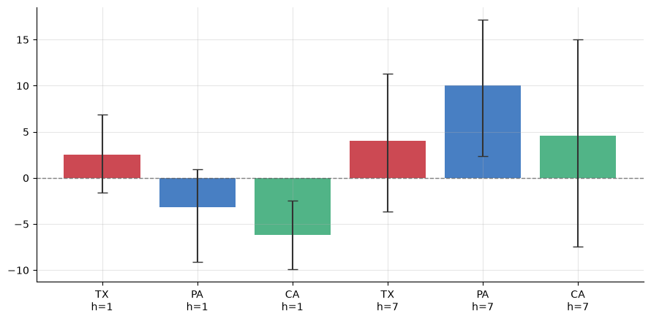
Fig. 6. HGB-versus-ridge effect sizes for Texas, Pennsylvania, and California at one- and seven-day horizons.
Applying dependent-error testing and multiplicity correction across these six state–horizon comparisons, the evidence for a general nonlinear advantage is therefore limited. Five of the six principal ridge-HGB comparisons provide no statistically significant evidence of different predictive accuracy after correction. The sixth, CA at one day, favors the linear model. As examined below, however, even this result is sensitive to feature representation, hyperparameter-selection chronology, and hyperparameter-search budget. No initially significant state-level comparison remains invariant to all of the methodological checks to which it is subjected.
These findings qualify, rather than contradict, previous reports of improved point accuracy from nonlinear and ensemble forecasting models [4], [14], [23], [24]. An apparent advantage at a particular state and forecast horizon can weaken once competing models are subjected to prospective tuning, dependent-error inference, and correction for multiple comparisons. Differences in reported performance across the literature may consequently reflect not only algorithmic capability but also the horizon and evaluation framework under which models are compared.

3.3 Robustness and diagnostic analyses
The first diagnostic examined whether nonlinear-model performance improves preferentially during large day-to-day changes in emissions. Fig. 7 relates the squared-error differential
$$d_{t}=e_{ridge,t}^{2}-e_{HGB,t}^{2}$$
to the magnitude of the day-to-day CO₂ ramp. The estimated slope was not significant in TX ($β_{1}=-5708$, $p=0.4024$, Holm $p=0.8048$) or PA ($β_{1}=1429$, $p=0.5240$, Holm $p=0.8048$). In CA, the relationship was significant and survived Holm correction ($β_{1}=-4516$, $p=0.0001$, Holm $p=0.0003$). Its direction, however, was opposite to the intuitive expectation that a nonlinear model should benefit more strongly during large emission changes: ridge's advantage increased rather than diminished as ramp magnitude increased. Large day-to-day emission changes therefore do not provide a general mechanism for explaining the relative advantage of HGB.
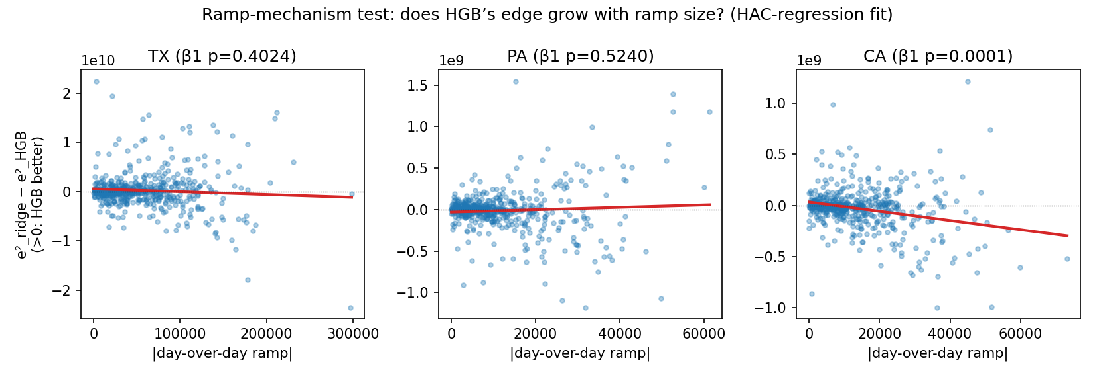
Fig. 7. HAC regression of ridge-versus-HGB loss differential on absolute day-over-day CO₂ ramp magnitude in Texas, Pennsylvania, and California.
A second diagnostic examined the joint influence of feature representation and hyperparameter-selection chronology on the CA one-day result. The 2×2 design compared ratio-encoded and explicit-CO₂ specifications under retrospective and prospective ridge regularization selection while holding HGB at a fixed configuration.
Table 10. Sensitivity of the CA one-day ridge-vs-HGB comparison to feature representation and hyperparameter-selection chronology (HGB held at a fixed configuration), with Holm correction across the four cells.
Features | α selection | Selected λ | R² Ridge | R² HGB | DM stat. | p (raw) | Holm p
Ratio-encoded | Retrospective | 30 | 0.820 | 0.818 | -0.303 | 0.7618 | 0.7618
Ratio-encoded | Prospective | 0.3 | 0.837 | 0.818 | -2.548 | 0.0111 | 0.0444
Explicit-CO₂ | Retrospective | 200 | 0.807 | 0.824 | +2.078 | 0.0382 | 0.1146
Explicit-CO₂ | Prospective | 3 | 0.834 | 0.824 | -1.335 | 0.1824 | 0.1824

None of the four cells produced a statistically significant HGB advantage after Holm correction. The ratio-encoded/retrospective specification produced $R^{2}=0.820$ for ridge and 0.818 for HGB ($p_{Holm}=0.7618$), providing no evidence that the least constrained combination systematically favors HGB.
The factorial analysis therefore does not support a simple causal explanation in which redundant target encoding and retrospective hyperparameter selection independently generate an HGB advantage. Instead, the comparison is sensitive to their interaction. Under retrospective regularization selection, changing from the ratio-encoded to the explicit-CO₂ representation shifted the point estimate toward HGB, although the difference did not survive correction ($p_{Holm}=0.1146$). Conversely, prospective selection under the ratio-encoded representation shifted the comparison toward ridge and remained significant after Holm correction ($p_{Holm}=0.0444$). Feature representation and model-selection chronology therefore interact rather than contributing additively.
The fixed HGB configuration used in this diagnostic achieved $R^{2}=0.824$ under the explicit-CO₂/prospective specification, slightly exceeding the $R^{2}=0.813$ obtained by the prospectively tuned HGB in the primary analysis. Validation-based model selection therefore selected an HGB configuration that generalized somewhat less effectively to the rolling-origin evaluation than the fixed configuration. Prospective tuning is thus not guaranteed to improve a particular realized out-of-sample estimate and may itself be influenced by temporal changes between the validation and subsequent forecast periods.
The sensitivity of the CA result to model selection was examined more stringently using the expanded hyperparameter search. Ridge was searched over 30 log-spaced regularization values and HGB over 60 configurations using three expanding-window temporal cross-validation folds within the initial selection window.
Table 11. Robustness of the CA and TX one-day comparisons to a substantially larger, nested-temporal-CV hyperparameter search.
State | Search budget | R² Ridge | R² HGB | DM stat. | p
CA | Primary (12 pts each) | 0.834 | 0.813 | -3.111 | 0.0020
CA | Expanded (30 ridge / 60 HGB, nested CV) | 0.833 | 0.822 | -1.307 | 0.1918
TX | Primary (12 pts each) | 0.745 | 0.758 | 1.196 | 0.2324
TX | Expanded (30 ridge / 60 HGB, nested CV) | 0.736 | 0.754 | 1.268 | 0.2053

Under the substantially larger search, the CA one-day comparison remained directionally ridge-favored ($R^{2}=0.833$ versus 0.822 for HGB), but the difference was no longer statistically significant ($DM=-1.307$, $p=0.1918$). The initially significant CA result therefore does not survive the expanded search. TX remained nonsignificant under the same procedure, consistent with the primary analysis.
Whether the change in CA reflects the absence of a genuinely robust ridge advantage or the particular configurations sampled by the larger HGB search cannot be resolved definitively. What is clear, however, is that the only three-state comparison surviving the initial multiplicity correction is not invariant to a materially broader hyperparameter search.
The dependence-related sensitivity analyses lead to a complementary conclusion. CA's one-day result remained significant across DM lags of 5, 7, and 14 days, with $p=0.0020$, 0.0027, and 0.0046, respectively. Its $ΔRMSE$ confidence interval also excluded zero for block-bootstrap lengths of 7, 14, and 28 days. PA at seven days showed comparable stability at the level of the individual comparison, with its DM $p$-value remaining nominally significant across the same lag values and its confidence interval excluding zero at all three block lengths. PA nevertheless remained nonsignificant under Holm correction across the six principal state–horizon comparisons.
Table 12. ΔRMSE% block-bootstrap 95% CI by block length, for the two state-horizon pairs.
State | Horizon | Block length | ΔRMSE% | 95% CI | Excludes zero
CA | 1 | 7 | -6.17 | [-9.93, -2.43] | Yes
CA | 1 | 14 | -6.17 | [-10.06, -2.24] | Yes
CA | 1 | 28 | -6.17 | [-9.98, -1.88] | Yes
PA | 7 | 7 | 10.06 | [2.20, 17.16] | Yes
PA | 7 | 14 | 10.06 | [1.87, 18.31] | Yes
PA | 7 | 28 | 10.06 | [1.37, 17.81] | Yes

These two forms of robustness answer different questions. Sensitivity to HAC lag and bootstrap block length concerns the stability of an individual comparison to reasonable dependence-related nuisance choices, whereas multiplicity correction asks whether the same comparison remains exceptional after accounting for all tests in the inferential family. PA at seven days satisfies the former standard but not the latter.
The final three-state sensitivity analysis restricted the state aggregates to facilities reporting on at least 95% of days. This criterion retained 36 of 132 facilities in TX, 11 of 73 in PA, and 4 of 109 in CA, representing 60.4%, 34.1%, and 9.4% of each state's total emissions, respectively. Correlations between the full and consistently reporting state-day series were 0.965, 0.632, and 0.738.
Table 13. Consistently-reporting-facility-subset rolling-origin comparison, one-day and seven-day horizons.
State | Horizon | Model | Consistently reporting facilities | R² (subset) | R² (full panel)
TX | 1 | Persistence | 36/132 | 0.690 | 0.716
TX | 1 | Ridge | 36/132 | 0.732 | 0.745
TX | 1 | HGB | 36/132 | 0.737 | 0.758
PA | 1 | Persistence | 11/73 | 0.912 | 0.912
PA | 1 | Ridge | 11/73 | 0.912 | 0.929
PA | 1 | HGB | 11/73 | 0.892 | 0.925
CA | 1 | Persistence | 4/109 | 0.768 | 0.766
CA | 1 | Ridge | 4/109 | 0.805 | 0.834
CA | 1 | HGB | 4/109 | 0.799 | 0.813
TX | 7 | Persistence | 36/132 | 0.255 | 0.237
TX | 7 | Ridge | 36/132 | 0.436 | 0.458
TX | 7 | HGB | 36/132 | 0.512 | 0.501
PA | 7 | Persistence | 11/73 | 0.555 | 0.339
PA | 7 | Ridge | 11/73 | 0.562 | 0.486
PA | 7 | HGB | 11/73 | 0.647 | 0.584
CA | 7 | Persistence | 4/109 | 0.273 | 0.065
CA | 7 | Ridge | 4/109 | 0.433 | 0.325
CA | 7 | HGB | 4/109 | 0.445 | 0.386

The model ordering in the full panel was HGB > ridge > persistence in four of the six state–horizon combinations-TX at both horizons and PA and CA at seven days-and ridge > HGB > persistence for PA and CA at one day. Restricting the panel to consistently reporting facilities preserved this ordering in five of the six cases. The only exception was PA at one day, where HGB fell below persistence under the restricted sample ($R^{2}=0.892$ versus 0.912), whereas it had been narrowly above persistence in the full panel (0.925 versus 0.912). Reporting composition can therefore alter a model ranking, although the broad ordering is preserved in most comparisons.
The restricted-panel analysis further shows that PA and CA state-level aggregates depend much more strongly than TX on facilities that do not report every day. The available data cannot distinguish whether this reflects measurement or submission gaps, genuinely intermittent operation of generating units, or some combination of both. Facility-level metadata on unit type and capacity factor would be required to distinguish these possibilities. From a forecasting perspective, however, reporting coverage should be treated as an input-quality characteristic of the state-level series rather than evaluated only through downstream forecast error.
Overall, the three-state analysis demonstrates why individual state–horizon superiority claims should be interpreted cautiously. Feature representation, hyperparameter-selection chronology, temporal evaluation design, dependence assumptions, reporting composition, and search budget can all influence the estimated difference between models. These diagnostics do not imply that every state is equally sensitive to each choice; rather, they identify methodological vulnerabilities that must be controlled before the larger nationwide pattern is interpreted.

3.4 Nationwide two-horizon benchmark and regional robustness
Extending the same evaluation framework to 47 eligible states reveals a substantially more structured pattern than is apparent from the three-state analysis alone. At the one-day horizon, ridge produced the better rolling-origin point estimate in 41 of 47 states, whereas at the seven-day horizon HGB produced the better estimate in 45 of 47 states. Both directional imbalances are far from the 50/50 split expected by chance under the binomial reference: $p=1.8×{10}^{-7}$at one day and $p=1.6×{10}^{-11}$at seven days.
Before correction for multiplicity, 36 of the 94 state–horizon comparisons were significant at $p<0.05$. Nineteen occurred at one day, of which 18 favored ridge and only one, WI, favored HGB. Seventeen occurred at seven days, and all favored HGB. After Holm correction across the complete 94-comparison family, four remained significant: FL and GA at one day, both favoring ridge, and IL and WV at seven days, both favoring HGB. The Benjamini-Hochberg procedure retained 14 comparisons, and all followed the same horizon-dependent direction. Of the 36 nominally significant comparisons, WI at one day was therefore the only result inconsistent with the dominant horizon pattern.
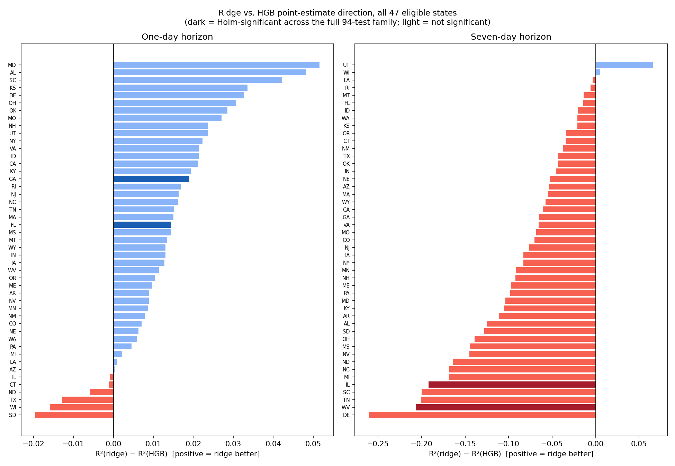
Fig. 8. Ridge-vs-HGB point-estimate direction (R² difference) for all 47 eligible states, by horizon. Dark bars are Holm-significant across the full 94-test family.
Table 14. Nationwide benchmark summary: counts of states favoring ridge vs. HGB, by horizon and evidentiary standard (47 states, 94 comparisons).
Horizon | Standard | Ridge favored | HGB favored
1-day | Point estimate (any margin) | 41 / 47 | 6 / 47
1-day | Nominal p<0.05 (uncorrected) | 18 / 47 | 1 / 47
1-day | Holm-significant (94-test family) | 2 / 47 | 0 / 47
1-day | BH-significant (94-test family) | 8 / 47 | 0 / 47
7-day | Point estimate (any margin) | 2 / 47 | 45 / 47
7-day | Nominal p<0.05 (uncorrected) | 0 / 47 | 17 / 47
7-day | Holm-significant (94-test family) | 0 / 47 | 2 / 47
7-day | BH-significant (94-test family) | 0 / 47 | 6 / 47

The same reversal is evident relative to the persistence baseline. Ridge significantly outperformed persistence in 40 of 47 states at one day but only 31 at seven days. HGB significantly outperformed persistence in 23 states at one day but 42 at seven days. Ridge is therefore the more dependable improvement over persistence at short horizons, whereas HGB assumes that role at the longer horizon.
The broader 94-test family also places the three-state findings in context. CA at one day, which was the sole family-wise-significant comparison when correction was performed across the original six TX/PA/CA tests, has $p_{Holm}=0.165$ when correction is instead applied across the complete nationwide family. It is therefore not significant under this broader reference class, although its direction remains consistent with 40 of the other 46 states at the one-day horizon. This reinforces the distinction between an isolated state-specific significance result and a systematic cross-state pattern.
A paired within-state analysis directly tests whether relative model performance shifts with horizon. For state s:
$$Δ_{s}\left(h\right)=R_{HGB}^{2}\left(s , h\right)-R_{ridge}^{2}\left(s , h\right)$$
and the within-state shift is:
$$Δ_{s}\left(7\right)-Δ_{s}\left(1\right)$$
This quantity was positive in 45 of 47 states, with a median of +0.093 and an interquartile range of [+0.049, +0.155]. The paired Wilcoxon signed-rank test strongly rejected the null of no shift ($W=12.0$, $p=9.9×{10}^{-13}$), as did the paired $t$-test ($t=9.70$, $p=1.1×{10}^{-12}$). The median one-day difference was -0.013 (IQR $\left[- , 0.021-0.007\right]$), whereas the median seven-day difference was +0.070 (IQR $\left[+ , 0.040+0.127\right]$).
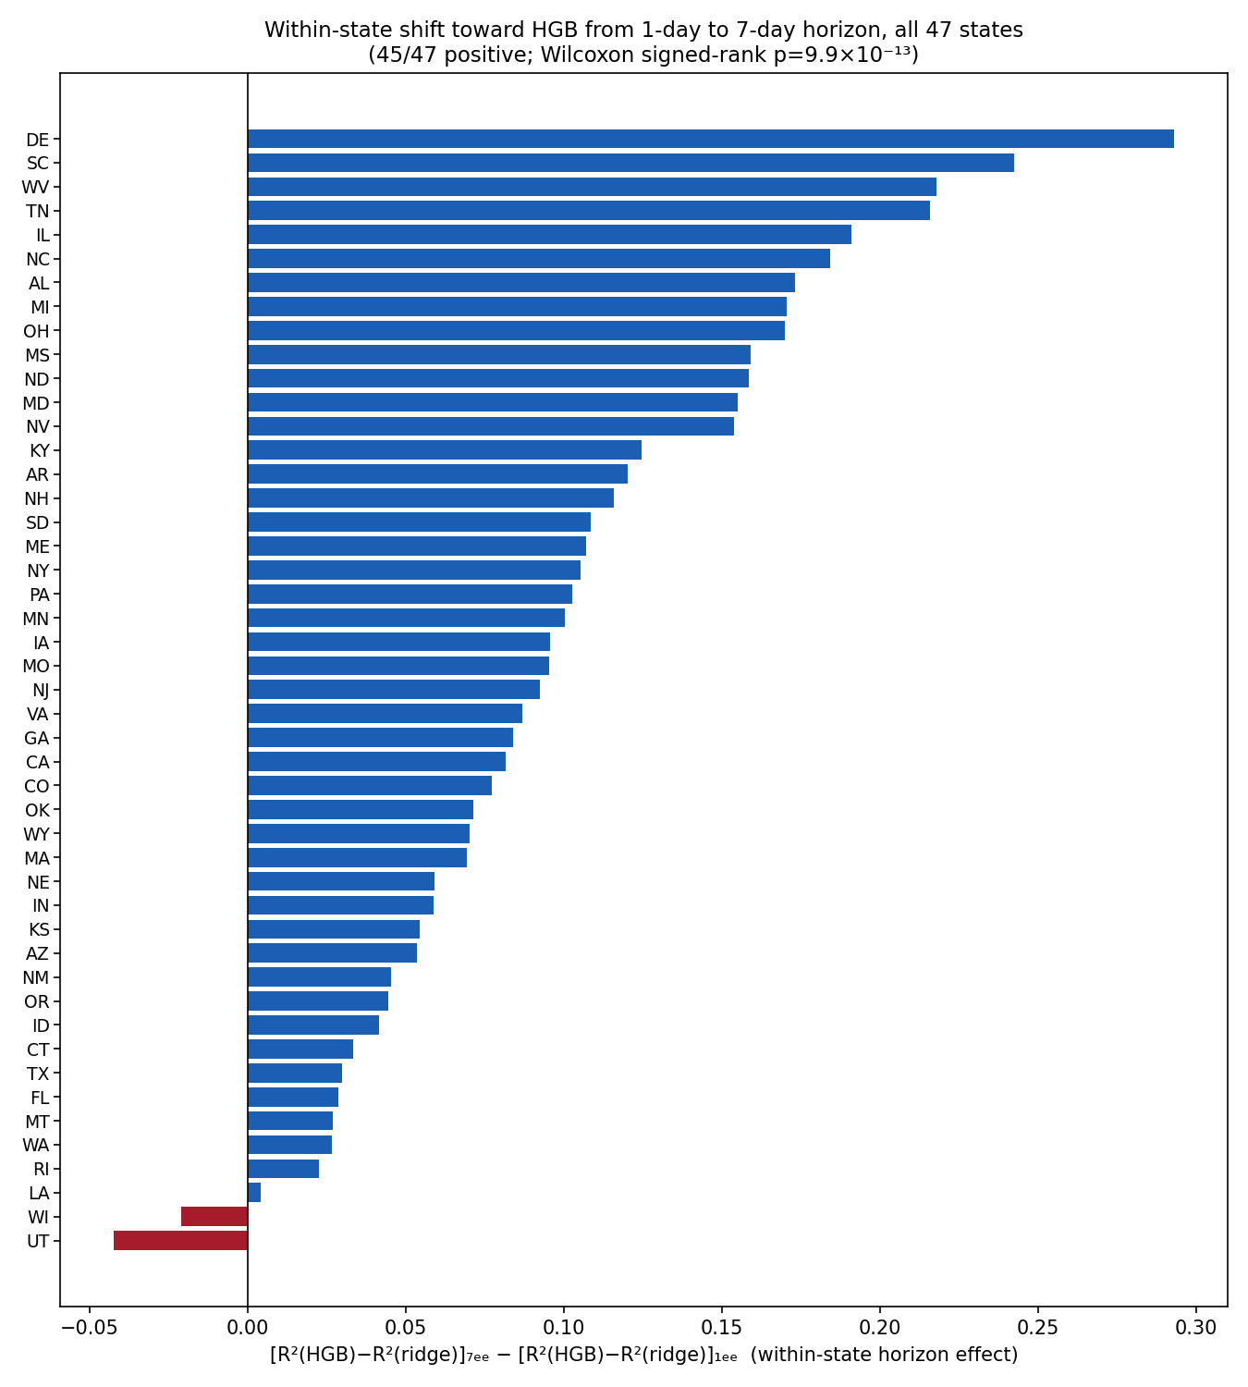
Fig. 9. Within-state change in relative HGB performance from the one-day to the seven-day horizon across all 47 eligible states.
Because U.S. state power systems are not fully independent, geographic consistency provides an important complement to the state-level analysis. Neighboring states may share interconnections, regional weather, fuel markets, and demand shocks, making complete independence implausible.
Table 15. Regional robustness: states favoring ridge at one day and HGB at seven days, by U.S. Census region.
Region | N states | Ridge favored, 1-day | HGB favored, 7-day
Northeast | 8 | 7 / 8 | 8 / 8
Midwest | 12 | 8 / 12 | 11 / 12
South | 16 | 15 / 16 | 16 / 16
West | 11 | 11 / 11 | 10 / 11

The same direction appears in every Census region. Even in the weakest regional result, the Midwest at one day, ridge retained the majority. No single geographic region therefore drives the nationwide pattern.
The nationwide finding was also tested for sensitivity to the initial hyperparameter-search budget. Under the expanded 30-ridge/60-HGB search, ridge produced the better one-day estimate in 42 of 47 states, compared with 41 under the primary search. At seven days, HGB remained preferred in 38 of 47 states, compared with 45 under the primary search. The longer-horizon pattern was therefore attenuated but not reversed. Both directional splits remained strongly inconsistent with chance ($p=2.5×{10}^{-8}$ and $p=2.5×{10}^{-5}$, respectively).
Fourteen of the 94 individual state–horizon comparisons changed which model had the better point estimate under the expanded search, five at one day and nine at seven days. Every reversal occurred where the original difference between models was already small. Search-budget sensitivity is therefore concentrated among near-ties rather than producing a systematic change in the nationwide conclusion.

3.5 Multihorizon crossover
The two-horizon nationwide result raises the more important question of how the transition develops between one and seven days and beyond. The seven-year analysis therefore evaluates 45 states at seven horizons, 1, 2, 3, 5, 7, 10, and 14 days-yielding 315 state, horizon comparisons.
For horizon $h$, define the national mean model difference as
$$Δ\left(h\right)=R_{HGB}^{2}\left(h\right)-R_{ridge}^{2}\left(h\right)$$
The resulting trajectory is smooth and nearly monotonic. At one day, Δ(h) is negative and its 95% confidence interval excludes zero, indicating a small but systematic ridge advantage. The gap approaches zero between two and three days, changes sign by three days, and becomes increasingly positive thereafter. From five days onward, the national mean HGB advantage has a confidence interval excluding zero.
Table 16. National summary of the ridge-HGB gap by horizon (45 states, bootstrap 95% CI).
Horizon (days) | Mean ΔR² (HGB−ridge) | 95% CI | States favoring HGB
1 | -0.0065 | [-0.0097, -0.0034] | 20.0%
2 | -0.0017 | [-0.0070, +0.0037] | 44.4%
3 | +0.0053 | [-0.0009, +0.0116] | 62.2%
5 | +0.0259 | [+0.0166, +0.0349] | 80.0%
7 | +0.0477 | [+0.0365, +0.0579] | 88.9%
10 | +0.0837 | [+0.0689, +0.0984] | 93.3%
14 | +0.1084 | [+0.0922, +0.1233] | 97.8%
The state-level directional proportions follow the same progression: the fraction favoring HGB increases from 20.0% at one day to 44.4% at two days, 62.2% at three days, 80.0% at five days, 88.9% at seven days, 93.3% at ten days, and 97.8% at fourteen days. The heatmap representation shows the same broad transition from ridge-favoring values at short horizons to HGB-favoring values as the horizon increases. New Mexico is the clearest exception, remaining ridge-favored throughout the tested horizon range.
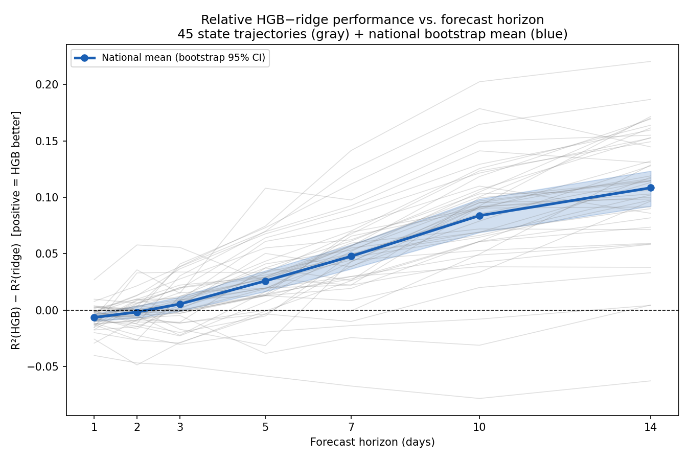
Fig. 10. $R^{2}\left(HGB\right)-R^{2}\left(ridge\right)$ versus forecast horizon: 45 individual state trajectories and the national bootstrap mean with 95% CI.
Fig. 10 shows this national mean alongside 45 individual state trajectories. The state-by-horizon heatmap in Fig. 11 displays the corresponding values for each state, revealing both the broad crossover and the few persistent exceptions.

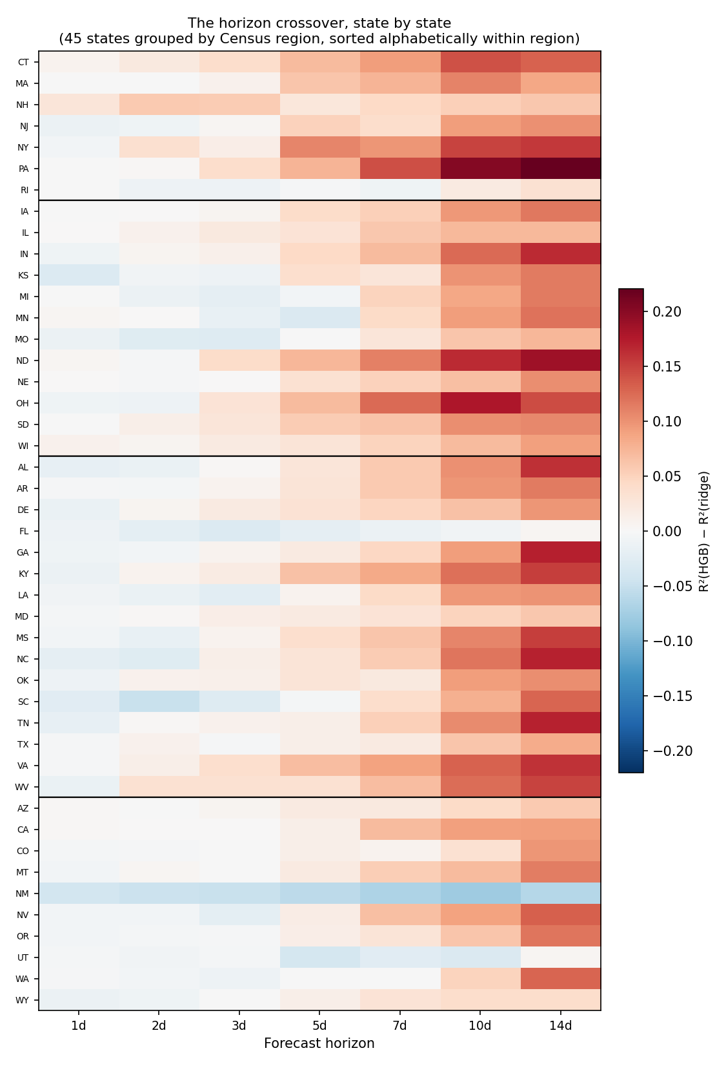
Fig. 11. State-by-horizon heatmap of ΔR² = R²(HGB) – R²(ridge), grouped by U.S. Census region. Positive values favor HGB; negative values favor ridge.
The geographic representation in Fig. 12 reinforces that the transition is distributed broadly rather than concentrated in a particular region. At one day, the map is predominantly ridge-favoring or close to neutral; by five, ten, and fourteen days, HGB-favoring values become progressively widespread. New Mexico remains the principal persistent exception.
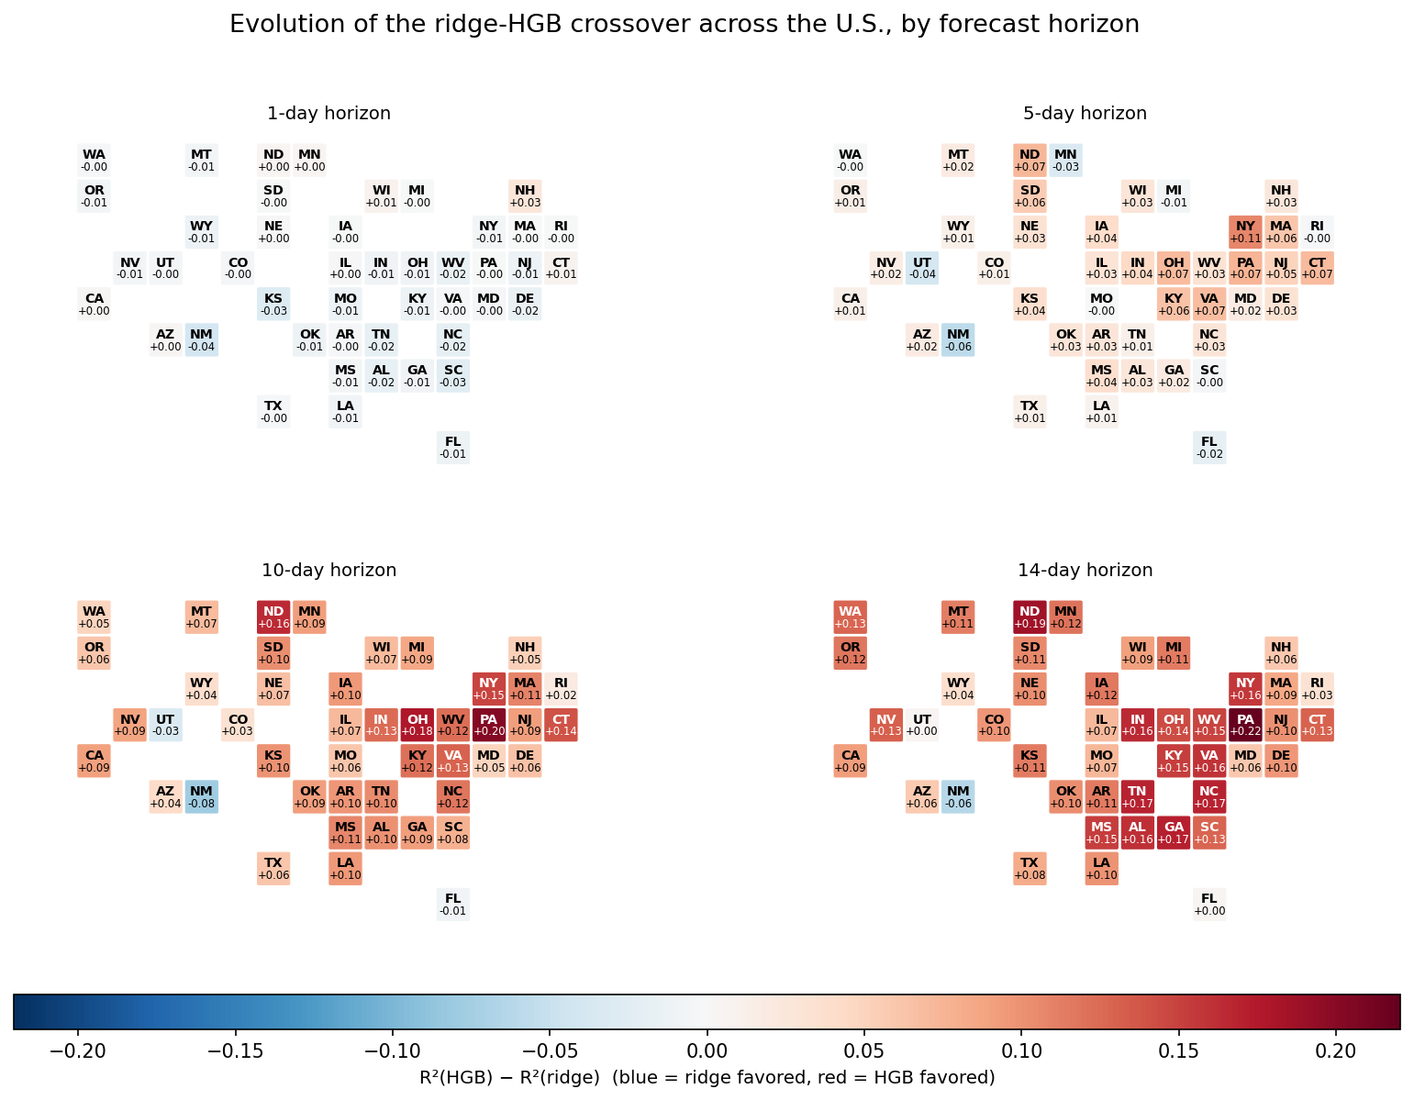
Fig. 12. Geographic distribution of $R^{2}\left(HGB\right)-R^{2}\left(ridge\right)$ at 1-, 5-, 10-, and 14-day horizons, shown as U.S. tile-grid maps.
A descriptive crossover horizon was also estimated for each state by linearly interpolating between the tested horizons bracketing:
$$Δ=0$$
This quantity should not be interpreted as a precisely identified physical threshold. Nine states were already marginally HGB-favored at the shortest tested horizon and are therefore left-censored at $≤1$ day rather than known to cross exactly at one day. New Mexico is right-censored beyond 14 days rather than demonstrated never to cross. Intermediate estimates also assume an approximately linear change between the discrete horizons tested.
Subject to these limitations, a crossover was identified for 44 of the 45 states. The median estimated crossover was 1.8 days, with an IQR of 1.1-3.2 days. Twenty-three states crossed within two days, whereas seven, Missouri, South Carolina, Michigan, Washington, Rhode Island, Florida, and Utah, did not cross until beyond five days. Utah had the latest estimated transition at approximately 13.5 days. The substantial state-to-state variation suggests that local persistence characteristics may influence when additional nonlinear flexibility becomes useful, although a formal analysis of state-specific persistence timescales would be required to test that hypothesis directly.
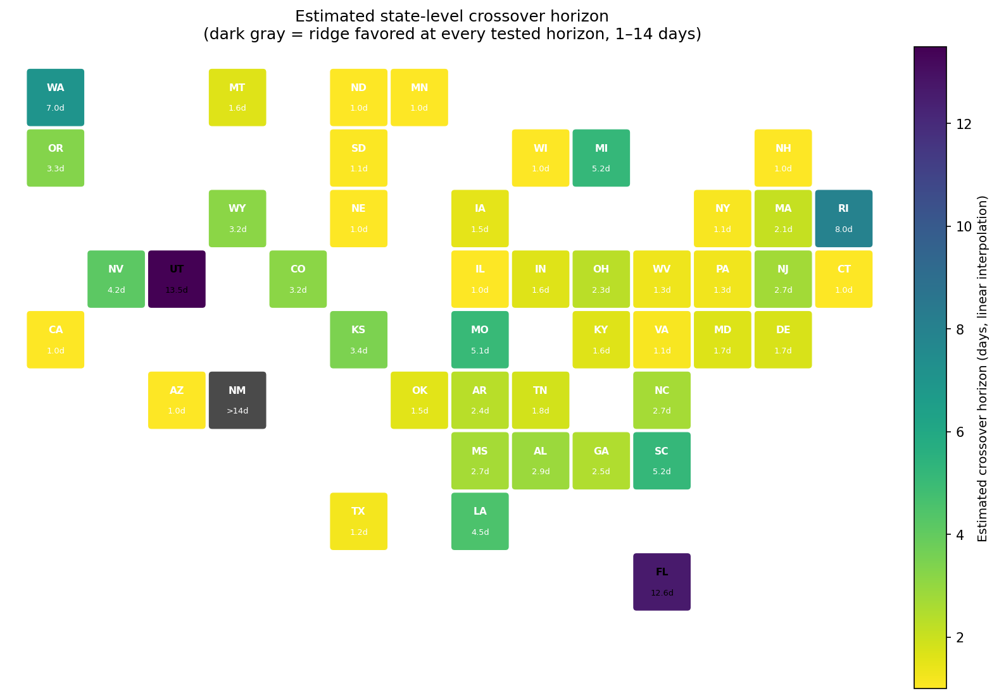
Fig. 13. Descriptive estimated crossover horizon per state.
The bootstrap national mean was supplemented with multiplicity correction across all 315 individual DM tests. Of these comparisons, 163 were nominally significant, 30 survived Holm correction, and 118 survived Benjamini-Hochberg correction. Importantly, all 30 Holm-significant comparisons were directionally consistent with the overall horizon pattern.
The Holm-significant subset is single-direction at every horizon, but this does not carry over to the larger, less conservative BH-significant subset: at h=2, 3, 5, and 7 the BH-significant comparisons include a mix of both directions (e.g. 5 ridge-favoring and 2 HGB-favoring at h=2), reflecting the region of the horizon curve where the national-mean CI is close to, or only just excluding, zero (Table 13). Only at h=1 and h≥10 is the BH-significant subset itself single-direction. Table 16b reports the ridge/HGB split for both corrections directly.
Table 17. Holm- and BH-corrected significance counts across the 315-test multihorizon family, by horizon and direction.
Horizon (days) | Nominal p<0.05 | Holm-sig. (ridge/HGB) | BH-sig. (ridge/HGB)
1 | 21 | 5 (5/0) | 11 (11/0)
2 | 10 | 1 (0/1) | 7 (5/2)
3 | 11 | 1 (0/1) | 8 (3/5)
5 | 19 | 2 (0/2) | 14 (2/12)
7 | 28 | 3 (0/3) | 17 (1/16)
10 | 37 | 8 (0/8) | 31 (0/31)
14 | 37 | 10 (0/10) | 30 (0/30)

The five Holm-significant ridge-favoring comparisons occur exclusively at the one-day horizon. All remaining Holm-significant comparisons favor HGB, including one at two days, one at three days, two at five days, and 21 at horizons of seven days or longer. The individual state-level inferential evidence therefore becomes increasingly HGB-favoring as the horizon increases, consistent with the national mean trajectory.
The multihorizon analysis establishes that the one-versus-seven-day reversal is not an artifact of selecting two isolated endpoints. Instead, relative model performance changes continuously with horizon, with a narrow region of approximate equivalence around two to three days and an increasingly pronounced HGB advantage thereafter.

3.6 Persistence decay and cluster-robust inference
The shape of the crossover is consistent with a specific statistical mechanism: progressive decay of autoregressive persistence. At short horizons, a large fraction of forecastable structure is already contained in the most recent emissions observations, allowing a regularized linear model to exploit that persistence efficiently. As the horizon increases, the predictive value of current emissions weakens, potentially increasing the contribution of nonlinear relationships among the remaining predictors.
Median persistence R² across the 45 states falls from 0.81 at one day to 0.57 at two days and 0.44 at three days, placing the largest initial decline close to the horizon at which the national mean ridge-HGB difference crosses zero. Median persistence falls further to 0.29 at five days, 0.22 at seven days, and below 0.04 at ten and fourteen days. Across all 315 state-horizon observations, persistence R² is strongly negatively associated with the HGB–ridge difference ($r=-0.68$): higher persistence corresponds to a greater relative advantage for ridge, whereas lower persistence corresponds to a greater HGB advantage.
The horizon effect was tested formally using cluster-robust regression. The estimated slope was 0.00945 R² points per additional forecast day. Because clustering changes the covariance estimate rather than the fitted coefficient, the point estimate is identical under state- and region-clustered specifications.
With standard errors clustered by state ($G=45$), the horizon effect was strongly significant ($t=14.31$, $p<{10}^{-6}$). This specification accounts for repeated horizon observations within each state but does not model dependence among different states. Clustering by Census region permits arbitrary dependence among states within a region. The corresponding asymptotic CR1 test yielded $t=9.29$ and $p=0.0026$. With only four regional clusters, however, this asymptotic result is not sufficiently reliable on its own.
The exact wild-cluster sign-flip test therefore provides an important small-cluster complement. With four regions, only 16 possible cluster-level sign assignments exist. Two of the 16 produced a statistic at least as extreme as the observed value, yielding an exact two-sided $p=0.125$. The regional test consequently lacks sufficient resolution for conventional 5% rejection. This should not be interpreted as evidence that the horizon effect is absent; rather, it reflects the limited inferential granularity available with only four independent regional clusters.
Table 18. Cluster-robust OLS regression of ΔR² (HGB-ridge) on forecast horizon, 315 state-horizon observations.
Clustering / test | N clusters | Horizon slope | SE | t statistic | p
Census region, asymptotic CR1 | 4 | 0.00945 | 0.00102 | 9.29 | 0.0026
Census region, exact wild-cluster permutation | 4 | 0.00945 | - | 9.29 | 0.125
State, asymptotic CR1 | 45 | 0.00945 | 0.00066 | 14.31 | <0.000001

Neither clustering scheme completely resolves dependence among states. State clustering is silent about cross-state dependence by construction, whereas the exact region-level test is limited by having only four clusters. The regional directional breakdown in Table 11 therefore remains important complementary evidence because the same one-day ridge and seven-day HGB pattern appears in all four Census regions without relying on the regression's clustering assumptions. The fitted regression crosses zero at approximately 2.03 days, closely matching the transition observed directly in the national mean trajectory.
Taken together, the persistence and cluster analyses support the interpretation that forecast horizon is not merely a labeling variable but is systematically associated with the relative value of model flexibility. The crossover coincides with short-horizon autoregressive predictability erodes, and the relative advantage of HGB increases as less of the future outcome can be recovered from persistence alone.
Fig. 14 summarizes the association between declining autoregressive persistence and the ridge–HGB performance gap. Panel (a) shows persistence R² across horizons, and panel (b) displays all 315 state-horizon observations with the pooled association (r = -0.68).
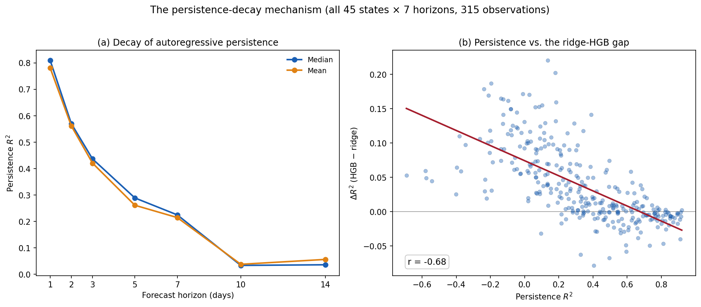
Fig. 14. Autoregressive persistence and the ridge–HGB performance gap across 45 states and seven forecast horizons. (a) Mean and median persistence R² by horizon. (b) Pooled association between persistence R² and ΔR² = R²(HGB) – R²(ridge) across 315 state-horizon observations.
Fig. 15 extends this regional check across the full horizon curve rather than the two endpoints in Table 11. All four Census regions trace the same rising shape, but not at the same pace: the West lags the other three regions at every horizon from three days onward, reaching only about +0.07 by fourteen days against roughly +0.11 to +0.12 elsewhere. Identifying what distinguishes the West's grids is a natural further question this manuscript does not resolve.
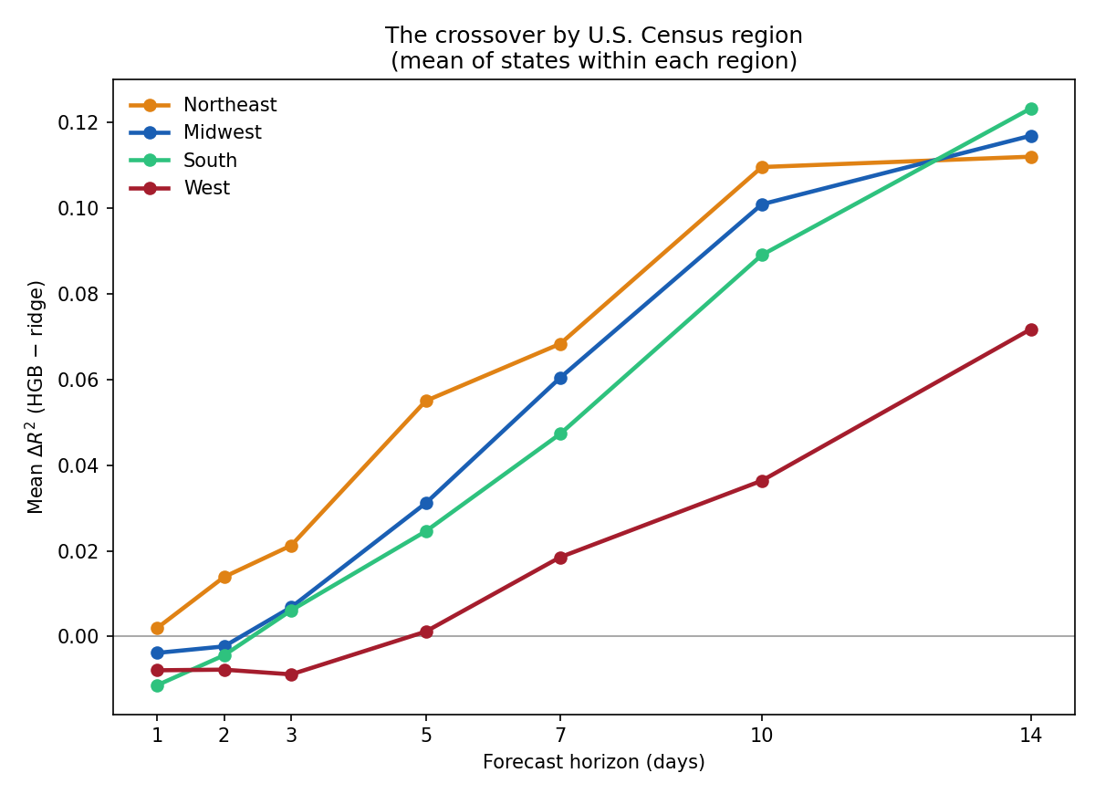
Fig. 15. The horizon-dependent crossover by U.S. Census region: the West lags the other three regions from three days onward.

3.7 Additive nonlinearity and robustness of the multihorizon crossover
The persistence analysis explains when the ridge-HGB ranking changes but does not by itself identify which aspect of HGB's additional flexibility is responsible. HGB can represent both nonlinear predictor-response relationships and higher-order interactions among predictors. The GAM analysis separates these possibilities because it permits smooth nonlinear effects for individual predictors while excluding cross-feature interactions by construction.
Across all 45 states, mean GAM performance closely follows HGB at every horizon. The mean GAM-ridge difference increases from $-0.0092$ at one day to $+0.1006$ at fourteen days. By contrast, HGB-GAM remains small relative to this gain throughout the horizon range and averages approximately zero across all 315 state-horizon observations.
Table 19. National GAM decomposition of the ridge-HGB gap, mean of all 45 states by horizon.
Horizon (days) | GAM - ridge | HGB - GAM | HGB - ridge (total gap)
1 | -0.0092 | +0.0027 | -0.0065
2 | -0.0020 | +0.0002 | -0.0017
3 | +0.0070 | -0.0016 | +0.0053
5 | +0.0346 | -0.0088 | +0.0259
7 | +0.0520 | -0.0043 | +0.0477
10 | +0.0799 | +0.0038 | +0.0837
14 | +0.1006 | +0.0078 | +0.1084
Across the complete 315-observation panel, GAM-ridge is strongly correlated with the total HGB–ridge gap ($r=0.90$). The GAM-ridge state-by-horizon heatmap is correspondingly very similar to the HGB-ridge heatmap, including New Mexico as the principal persistent exception. The nationwide results therefore indicate that the dominant long-horizon gain associated with HGB can already be recovered by an interaction-free additive nonlinear model.
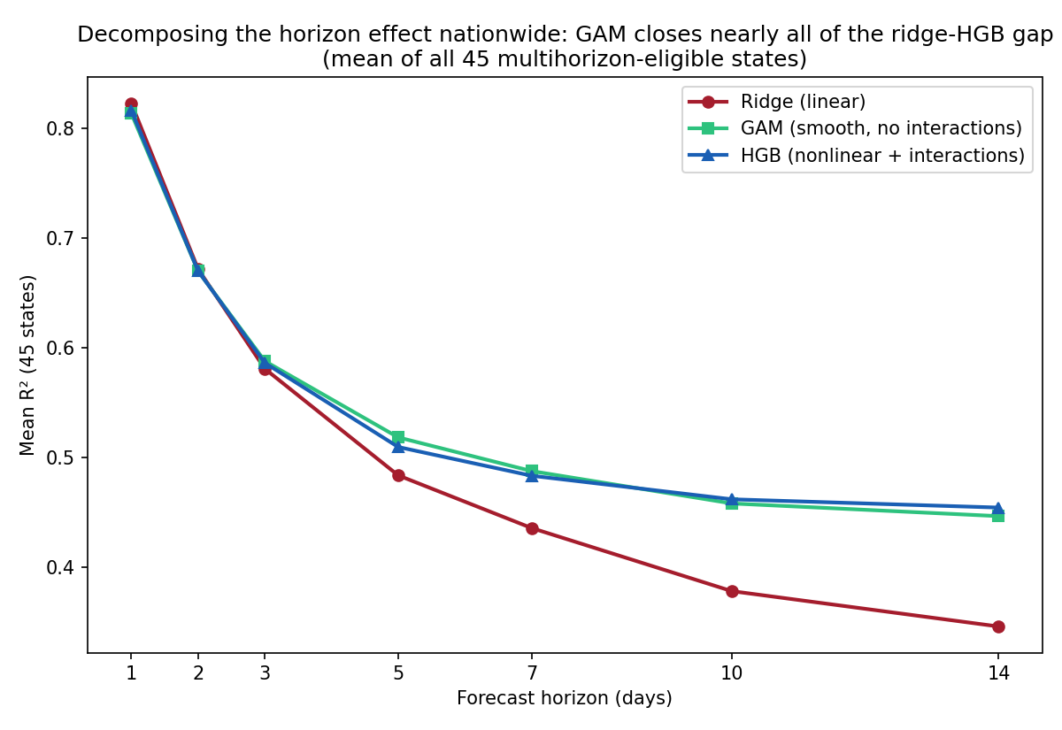
Fig. 16. Nationwide mean R² by forecast horizon for ridge regression, GAM, and HGB across all 45 multihorizon-eligible states.
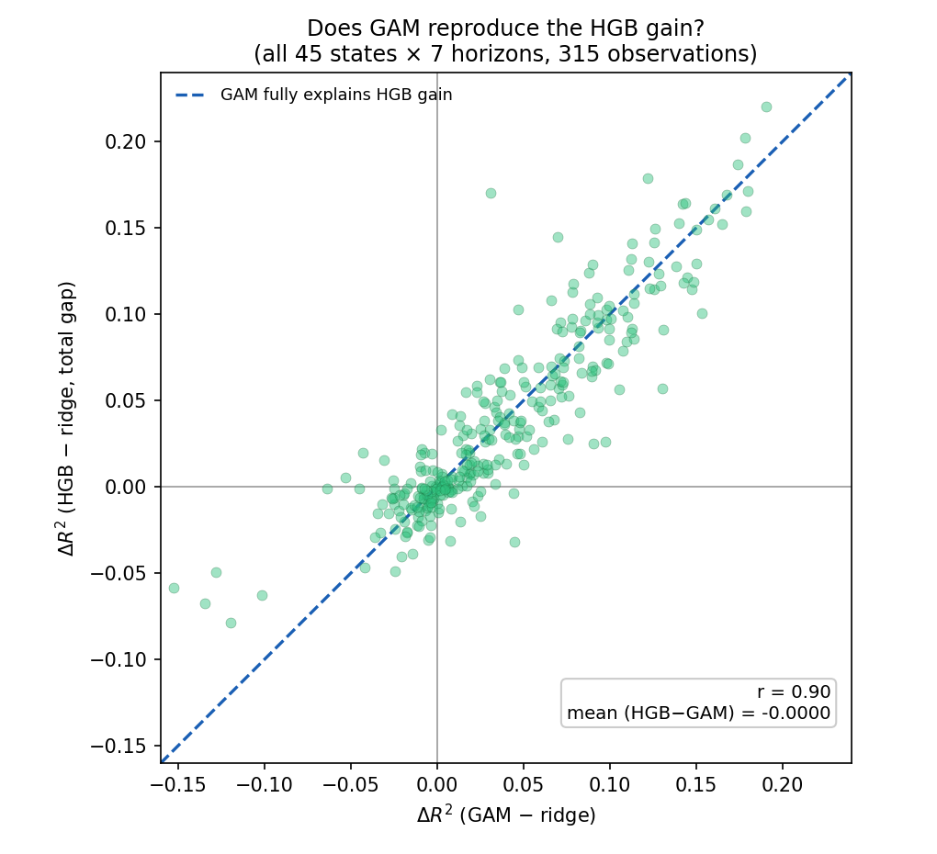
Fig. 17. GAM-ridge versus the total HGB-ridge gap, all 45 states × 7 horizons. Points near the dashed identity line indicate GAM alone reproduces the HGB advantage.
Fig. 18 retains the original three-state illustration of the same pattern. Averaged across TX, PA, and CA, the GAM–ridge difference increases from $-0.0062$ at one day to $+0.1242$ at fourteen days, closely tracking the overall ridge-HGB gap. The residual HGB-GAM difference remains comparatively small and shows no corresponding monotonic horizon trend.
Table 20. GAM decomposition of the ridge-HGB gap, mean of TX/PA/CA by horizon.
Horizon (days) | GAM - ridge | HGB - GAM | HGB - ridge (total gap)
1 | -0.0062 | +0.0059 | -0.0003
2 | +0.0031 | +0.0015 | +0.0046
3 | +0.0145 | -0.0026 | +0.0119
5 | +0.0519 | -0.0183 | +0.0336
7 | +0.0742 | +0.0023 | +0.0765
10 | +0.1116 | +0.0063 | +0.1179
14 | +0.1242 | +0.0070 | +0.1312

PA provides the clearest separation: at fourteen days, GAM-ridge reaches $+0.191$, whereas HGB-GAM is only $+0.030$. TX and CA show smaller but qualitatively similar patterns. Whatever additional nonlinear structure becomes useful at longer horizons, the results indicate that GAM already captures most of it with an explicitly interaction-free specification. Most of the value of increased complexity as persistence decays is therefore reproducible by smooth univariate nonlinearities rather than requiring interactions among CO₂-history, calendar, and operational predictors.
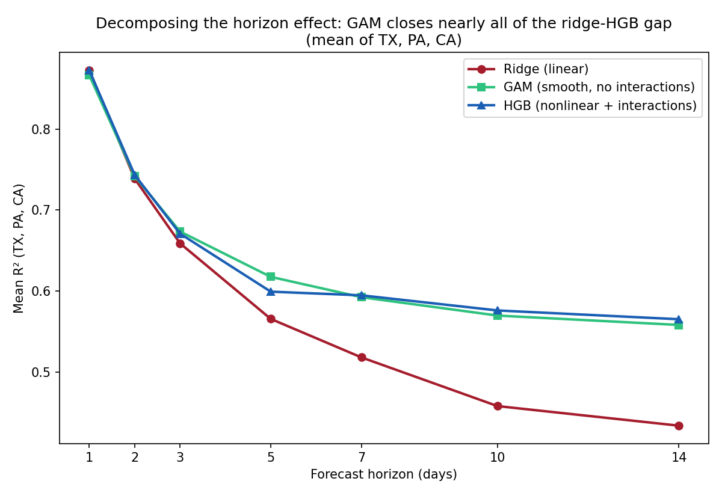
Fig. 18. Mean R² by forecast horizon for ridge regression, GAM, and HGB in Texas, Pennsylvania, and California.
A final robustness analysis examined whether the complete 1-14-day crossover persists under substantially broader hyperparameter searches. The full 45-state × seven-horizon sweep was repeated using 30 ridge regularization values and 60 HGB configurations instead of the primary 12-point searches.
The resulting national trajectory was essentially unchanged. At one day, the expanded search produced a mean HGB-ridge difference of $-0.0075$, compared with $-0.0065$ under the primary specification, and both confidence intervals excluded zero. Both specifications crossed zero between two and three days and showed confidence intervals favoring HGB from five days onward. At fourteen days, the expanded-search difference remained large at $+0.1020$, compared with $+0.1084$ under the primary search.
Table 21. National mean R²(HGB)-R²(ridge) by horizon, primary versus expanded hyperparameter search (45 states).
Horizon (days) | Primary (12-pt grids) | Expanded (30-ridge/60-HGB) | Absolute difference
1 | -0.0065 | -0.0075 | 0.0010
2 | -0.0017 | -0.0006 | 0.0011
3 | +0.0053 | +0.0058 | 0.0004
5 | +0.0259 | +0.0310 | 0.0052
7 | +0.0477 | +0.0499 | 0.0022
10 | +0.0837 | +0.0812 | 0.0026
14 | +0.1084 | +0.1020 | 0.0064

Across the seven horizons, the national mean curves from the primary and expanded searches correlate at $r=0.998$. The largest absolute difference between them at any single horizon is only 0.0064 R² points, an order of magnitude smaller than the overall change in the ridge-HGB gap across the horizon range. Search-budget limitations therefore do not explain the multihorizon crossover.
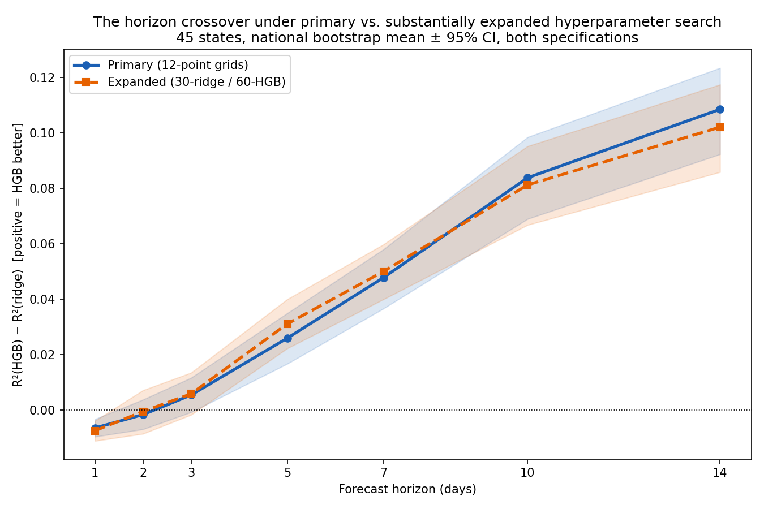
Fig. 19. Horizon crossover under the primary 12-point grids versus the expanded 30-ridge/60-HGB search: national bootstrap mean ± 95% CI, both specifications, all 45 states.
The combined evidence changes the appropriate framing of model comparison for power-sector CO₂ forecasting. Asking whether HGB or ridge is generally superior is not well posed because the answer depends systematically on forecast horizon. Ridge is favored at the shortest horizon, when autoregressive persistence remains strong; the models become approximately equivalent around two to three days; and HGB gains progressively as the horizon increases and persistence collapses. The GAM decomposition further shows that most of this aggregate long-horizon advantage can be reproduced through smooth additive nonlinearities without explicit higher-order interaction terms.
Importantly, the crossover is geographically widespread, strongly supported under state-clustered inference, and essentially unchanged under a substantially larger hyperparameter search. The region-clustered exact test is necessarily inconclusive because only four Census-region clusters are available, but all four regions display the same directional horizon pattern. The horizon-dependent change in the value of model complexity is therefore substantially more robust than any individual state-level or single-horizon superiority claim identified in the three-state analysis.

4. Limitations and future directions
Several limitations define the scope of the present findings. First, the primary model comparison is restricted to three specific levels of functional flexibility: ridge regression, a generalized additive model (GAM), and histogram gradient boosting (HGB). These models represent linear, additive-nonlinear, and interaction-capable formulations, respectively, and are evaluated nationwide in Section 3.7. The results therefore establish how these particular model classes behave as forecast horizon changes rather than supporting a universal conclusion about model complexity. XGBoost and LSTM-based variants were examined only in supplementary analyses and were not evaluated under the same complete prospective framework as the primary models (Section 2.5). Classical statistical time-series models, such as seasonal-naive and ARIMA formulations, and an independent implementation of gradient boosting were not included. Their omission should not be interpreted as evidence that they would exhibit different horizon-dependent behavior; extending the model hierarchy to these alternatives would provide an important test of the generality of the present findings.
Second, several detailed methodological diagnostics were conducted only for TX, PA, and CA. These include the feature-group ablation, aligned-window evaluation, feature-representation and hyperparameter-chronology analysis, and expanded nested temporal-CV retuning examined in Section 3.3. In contrast, the multihorizon crossover, its association with persistence decay, and the GAM decomposition were evaluated nationwide across the 45-state panel (Sections 3.5-3.7). The present analysis therefore establishes that the principal horizon-dependent pattern and the contribution of additive nonlinearity generalize geographically, but it does not determine whether the state-specific sensitivities observed in the three-state case study are typical of the broader panel. Nor does it identify which individual nonlinear predictor–response relationships account for the GAM improvement in each state. State-level decomposition of the fitted GAM functions and nationwide replication of the remaining diagnostic analyses would provide a natural extension.
Third, the consistently reporting facility analysis in Section 3.3 cannot distinguish incomplete reporting from genuine intermittent generator operation. The restricted and full-panel results show that state-level aggregates, particularly for PA and CA, are sensitive to which facilities contribute observations, but the CAMPD variables used here do not provide sufficient information to identify the source of that variation. Facility-level characteristics such as unit type, capacity factor, operating status, and reporting history would be required to separate data-quality effects from genuine operational intermittency.
Fourth, the analysis is conducted exclusively at daily resolution. CAMPD also provides hourly observations, which could support evaluation at substantially shorter forecast horizons and reveal whether the model-complexity crossover observed here persists at intraday timescales. The present findings should therefore be interpreted as applying to daily power-sector CO₂ forecasting rather than to higher-frequency operational forecasting more generally.
Fifth, although the multihorizon analysis extends the observation window to seven complete years from 2019 through 2025 (Section 2.6), this remains substantially shorter than the full historical record available through EPA's Part 75 monitoring program. The period also includes the 2020 COVID-19 demand disruption within the historical information available to subsequent rolling-origin models. The present study does not separately evaluate whether the location or magnitude of the crossover differs across pre- and post-2020 periods or under other structural changes, such as fuel-price cycles, generation-fleet turnover, or different rates of renewable deployment. Longer historical windows and explicitly regime-stratified analyses would be needed to establish the temporal stability of the horizon effect.
Sixth, the forecasts are conditional on a finalized end-of-day information set. Same-day values of gross load, heat input, SO₂, NO_{x}, and related operational variables are treated as available when forecasting emissions at future horizons, as defined in Section 2.3. Whether all such measurements would be available without delay to an operational forecast issued at the close of day t is not established here. The study should therefore be interpreted as a controlled comparison of forecasting models under a common realized information set rather than as a real-time deployment benchmark. An operational extension would replace unavailable contemporaneous inputs with forecasts or nowcasts of quantities such as load, weather, generation mix, and other system conditions.
Finally, the analysis evaluates statistical forecasting performance rather than the downstream value of the forecasts themselves. The practical benefit of matching model flexibility to forecast horizon will ultimately depend on the decision problem in which the forecasts are used. For applications such as carbon-aware load scheduling [21], for example, an improvement in R² or RMSE is valuable only to the extent that it changes scheduling decisions, emissions outcomes, operating costs, or other application-specific objectives. Linking the horizon-dependent forecasting results established here to such downstream decision metrics is therefore an important next step.

5. Conclusion
Across 45 U.S. states, seven years (2019-2025), and seven forecast horizons (1-14 days), the relative performance of ridge regression and histogram gradient boosting (HGB) traces a smooth, nearly monotonic crossover rather than a fixed ranking: ridge is favored at one day, the gap crosses zero around three days, and HGB is favored by a growing margin out to fourteen days. This crossover remains significant once dependence among observations is modeled directly rather than left as a caveat: decisively so when accounting for repeated horizon observations within each state (45 clusters, p<10⁻⁶); a complementary test for dependence among states within a region (only 4 clusters) lacks the resolution for conventional significance under exact small-sample inference (p=0.125), though the raw regional pattern remains directionally consistent in all four regions. The crossover also tracks a specific, tested mechanism nationwide: it coincides closely with the decay of autoregressive persistence (r=-0.68 between persistence R² and the ridge-HGB gap across 315 observations). A genuine additive-spline model with no interaction terms, fit nationwide across all 45 states, closes nearly all of the gap at long horizons (HGB-GAM stays small relative to this gain and averages approximately zero across the full panel), indicating that higher-order interactions are not required to reproduce most of the value of complexity as persistence decays.
This nationwide, multihorizon, mechanistically grounded result rests on a detailed three-state case study (TX, PA, CA) that shows why single-state, single-horizon superiority claims are fragile even when nominally significant: once feature representation, hyperparameter-selection chronology, evaluation protocol, and hyperparameter search budget were controlled consistently, the one comparison that initially appeared robust (CA at one day) did not survive a substantially larger hyperparameter search. Individual state-level significance remains this fragile at nationwide scale, only 4 of 94 two-horizon comparisons survive Holm correction, but the horizon-dependent pattern itself does not: it is the more robust finding, not the exception requiring caveats.
The broader implication is that asking whether a nonlinear model is generally superior to a linear one for power-sector CO₂ forecasting is not a well-posed , and has a nationwide empirical answer here: additional model complexity becomes valuable is well posed, and has a specific answer here, established nationwide rather than in a handful of states: additional nonlinear flexibility becomes increasingly valuable as autoregressive persistence decays, and most of that long-horizon gain is reproduced by smooth additive nonlinearities, showing that explicit higher-order interactions are not required to reproduce most of the observed aggregate advantage. Testing this candidate explanation more directly, decomposing which specific univariate relationships the GAM captures state by state, adding classical statistical baselines and a second boosting implementation, and connecting the horizon-dependent choice of model to a downstream application such as emissions-aware load scheduling, would extend this account from a well-supported empirical pattern toward a fuller mechanistic and practical understanding.

Data Availability
The empirical analysis uses U.S. EPA CAMPD daily facility-aggregation exports for 2019-2025 [22]. The source data are publicly available through the U.S. EPA Clean Air Markets Program Data portal: https://campd.epa.gov/

CRediT Authorship Contribution Statement
Ikram Moulay: Conceptualization, Visualization, Investigation, Writing – original draft, Writing – review & editing, Data curation, Methodology; Moussa Redah: Visualization, Investigation, Writing – review & editing, Data curation; Sahar Merrouche: Conceptualization, Visualization, Investigation, Editing. Yousef A. Alsunni: Revision, Supervision, Writing – review & editing; Omar J. Hammad: Revision, Investigation, Supervision, Writing – review & editing

Declaration of Competing Interest
The authors declare that they have no known competing financial interests or personal relationships that could have appeared to influence the work reported in this paper.

Acknowledgments
The authors acknowledge the support provided by the Deanship of Research Oversight and Coordination (DROC).

References

[1] Ali, M., Khan, D. M., Alshanbari, H. M., & Odhah, O. H. (2025). Forecasting carbon dioxide emission using hybrid machine learning and nonlinear data decomposition methods. IEEE Access, 13, 212942–212958. https://doi.org/10.1109/ACCESS.2025.3630867

[2] Benjamini, Y., & Hochberg, Y. (1995). Controlling the false discovery rate: A practical and powerful approach to multiple testing. Journal of the Royal Statistical Society: Series B, 57(1), 289–300.

[3] Bergmeir, C., & Benítez, J. M. (2012). On the use of cross-validation for time series predictor evaluation. Information Sciences, 191, 192–213. https://doi.org/10.1016/j.ins.2011.12.028

[4] Bokde, N., Tranberg, B., & Bruun Andresen, G. (2021). Short-term CO2 emissions forecasting based on decomposition approaches and its impact on electricity market scheduling. Applied Energy, 281, Article 116061. https://doi.org/10.1016/j.apenergy.2020.116061

[5] Cameron, A. C., Gelbach, J. B., & Miller, D. L. (2008). Bootstrap-based improvements for inference with clustered errors. The Review of Economics and Statistics, 90(3), 414–427. https://doi.org/10.1162/rest.90.3.414

[6] Chen, T., & Guestrin, C. (2016). XGBoost: A scalable tree boosting system. In Proceedings of the 22nd ACM SIGKDD International Conference on Knowledge Discovery and Data Mining (pp. 785–794). Association for Computing Machinery.

[7] Chicco, D., Warrens, M. J., & Jurman, G. (2021). The coefficient of determination R-squared is more informative than SMAPE, MAE, MAPE, MSE and RMSE in regression analysis evaluation. PeerJ Computer Science, 7, Article e623.

[8] Diebold, F. X., & Mariano, R. S. (1995). Comparing predictive accuracy. Journal of Business & Economic Statistics, 13(3), 253–263.

[9] Efron, B., & Tibshirani, R. J. (1994). An introduction to the bootstrap. Chapman & Hall/CRC.

[10] Harvey, D., Leybourne, S., & Newbold, P. (1997). Testing the equality of prediction mean squared errors. International Journal of Forecasting, 13(2), 281–291.

[11] Hastie, T., & Tibshirani, R. (1986). Generalized additive models. Statistical Science, 1(3), 297–310.

[12] Hochreiter, S., & Schmidhuber, J. (1997). Long short-term memory. Neural Computation, 9(8), 1735–1780.

[13] Holm, S. (1979). A simple sequentially rejective multiple test procedure. Scandinavian Journal of Statistics, 6(2), 65–70.

[14] Jin, Y., Sharifi, A., Li, Z., Chen, S., Zeng, S., & Zhao, S. (2024). Carbon emission prediction models: A review. Science of the Total Environment, 927, Article 172319.

[15] Künsch, H. R. (1989). The jackknife and the bootstrap for general stationary observations. The Annals of Statistics, 17(3), 1217–1241.

[16] Leerbeck, K., Bacher, P., Grønborg Junker, R., Goranović, G., Corradi, O., Ebrahimy, R., Tveit, A., & Madsen, H. (2020). Short-term forecasting of CO2 emission intensity in power grids by machine learning. Applied Energy, 277, Article 115527.

[17] Maji, D., Shenoy, P., & Sitaraman, R. K. (2022). CarbonCast: Multi-day forecasting of grid carbon intensity. In Proceedings of the 9th ACM International Conference on Systems for Energy-Efficient Buildings, Cities, and Transportation (pp. 198–207). Association for Computing Machinery.

[18] Newey, W. K., & West, K. D. (1987). A simple, positive semi-definite, heteroskedasticity and autocorrelation consistent covariance matrix. Econometrica, 55(3), 703–708.

[19] Pedregosa, F., Varoquaux, G., Gramfort, A., Michel, V., Thirion, B., Grisel, O., Blondel, M., Prettenhofer, P., Weiss, R., Dubourg, V., Vanderplas, J., Passos, A., Cournapeau, D., Brucher, M., Perrot, M., & Duchesnay, E. (2011). Scikit-learn: Machine learning in Python. Journal of Machine Learning Research, 12, 2825–2830.

[20] Politis, D. N., & Romano, J. P. (1994). The stationary bootstrap. Journal of the American Statistical Association, 89(428), 1303–1313.

[21] Radovanović, A., Koningstein, R., Schneider, I., Chen, B., Duarte, A., Roy, B., Xiao, D., Haridasan, M., Hung, P., Care, N., Talukdar, S., Mullen, E., Smith, K., Cottman, M., & Cirne, W. (2023). Carbon-aware computing for datacenters. IEEE Transactions on Power Systems, 38(2), 1270–1280.

[22] U.S. Environmental Protection Agency. (2026). Clean Air Markets Program Data (CAMPD) [Data set]. https://campd.epa.gov/

[23] Yao, X., Zhang, H., Wang, X., Jiang, Y., Zhang, Y., & Na, X. (2024). Which model is more efficient in carbon emission prediction research? Environmental Science and Pollution Research, 31, 19500–19515.

[24] Zhao, Q., Xiang, W., Huang, B., Wang, J., & Fang, J. (2022). Optimised extreme gradient boosting model for short term electric load demand forecasting of regional grid system. Scientific Reports, 12, Article 19107. https://doi.org/10.1038/s41598-022-22024-3

[25] IPCC. (2023). Climate Change 2023: Synthesis Report. Contribution of Working Groups I, II and III to the Sixth Assessment Report of the Intergovernmental Panel on Climate Change [Core Writing Team, H. Lee and J. Romero (Eds.)]. IPCC, Geneva, Switzerland. https://doi.org/10.59327/IPCC/AR6-9789291691647

[26] International Energy Agency. (2026). Global Energy Review 2026. IEA, Paris.

[27] International Energy Agency. (2025). Electricity 2025: Analysis and Forecast to 2027. IEA, Paris.

